Scripts User Manual

This manual is a guide to setting up and using CRMC’s scripts. The first section is dedicated to RayStation scripts, the second to all other scripts. There is both technical/implementation information aimed at scripters, as well as “how-to” usage information for any end user.

Contents

RayStation Scripts 5

Info for Scripters 5

How to Implement a Script in RayStation 5

Testing 6

Constants 6

Code Duplication 7

Parameters 7

Comments 7

Docstrings 7

Info for End Users 7

Script Descriptions 7

Scripts You Should Not Use 7

Script Validation Message 7

User Manual Sections 8

Add Box to External 8

Assumptions 9

Example 9

Coming Soon 10

Add Clinical Goals 10

Assumptions 12

Example 12

Coming Soon 13

Add Couch 14

Assumptions 14

Warnings 14

Example 14

Center Couch 15

Assumptions 15

Warnings 15

Center Geometries 16

Assumptions 16

Example 16

Coming Soon 17

Contour Chestwall 17

Assumptions 19

Warnings 19

Example 19

Coming Soon 20

Compare Contours 20

Assumptions 20

Example 20

Convert Virtual Jaw to MLC 22

Assumptions 22

Example 23

Copy Beam Set 24

Assumptions 25

Example 25

Copy Exam 25

Assumptions 26

Under the Hood 26

Example 26

Copy Exam with Plans 28

Assumptions 28

Under the Hood 29

Example 29

Copy Opt Stuff 31

Assumptions 31

Example 31

Coming Soon 32

Copy Plan to New CT or Merge Beam Sets 32

Assumptions 33

Warnings 33

Under the Hood 33

Example 34

Coming Soon 34

Copy Plan without Changes 35

Example 35

Create QA Plan 36

Assumptions 37

Example 37

Coming Soon 37

Delete Empty ROIs 38

Assumptions 38

Example 38

Coming Soon 38

Dose Grid Box 38

Assumptions 39

Example 39

Exclude from MOSAIQ Export 39

Assumptions 40

Example 40

Export DVH Curves 41

Assumptions 42

Example 42

Export Line Doses 44

Export to Test Patient 45

Extend Exam 45

Under the Hood 45

Assumptions 45

Example 46

Coming Soon 46

Generate Shifts Comments 46

Assumptions 47

Example 47

Last Modified Times 49

Assumptions 49

Example 49

List Patients 50

Example 51

Coming Soon 52

Localize to Beam Iso 52

Assumptions 52

Under the Hood 52

Example 53

Parse Logfiles 54

Example 56

Plan Check 57

Assumptions 61

Under the Hood 61

Example 61

Coming Soon 62

Plan Quality Metrics 62

Assumptions 63

Example 63

Coming Soon 64

Prepare Exams 64

Assumptions 65

Warnings 65

Example 65

Print Report 66

QACT Adaptive Analysis 66

Assumptions 66

Warnings 67

Example 67

SBRT Lung Analysis 69

Assumptions 70

Example 71

Coming Soon 73

Scale Clinical Goals 73

Assumptions 74

Approved Plans 74

Example 74

Scale Objectives and Constraints 75

Assumptions 75

Approved Plans 75

Example 75

Show Non-Empty Geometries 77

Structure Names and Colors 77

Assumptions 77

Warnings 77

Example 77

Coming Soon 79

Structure Propagation 4DCT 79

Example 79

Other Scripts 80

Creating an Executable 80

Info for End Users 80

ChromeDefaultBrowser 80

Dependencies 81

Implementation 81

Light-Rad Coincidence 81

Example 81

Set CRMC ROI Colors 82

# RayStation Scripts

## Info for Scripters

### How to Implement a Script in RayStation

See RaySearch's official Scripting Guidelines for comprehensive coverage of how to implement a script in RayStation, but following is CRMC’s preferred system.

RayStation scripts are stored in T:\Physics\KW\med-phys-scripts\RayStation. Each “main” script defines a function with the same name as the file. The “blurb” scripts are in the Blurbs folder. Each “blurb” script has the same name as the “main” script prepended with an underscore, and simply imports and calls the function from the “main” script. The “blurb” script is imported into RayStation. Separating the files in this way keeps us from having to invalidate, edit in RayStation or reimport from file, revalidate, and save the script, every time we change the code.

We always use the module General and our custom RayStation scripting environment CPython 3.8, and we give the scripts in RayStation, more human-friendly names than the script filenames.

Typically, the first line of the script’s section in this manual is appropriate for the script’s **Comment** in RayStation. Additionally, if the script saves a patient (search the script file for patient.Save()), append *SAVES PATIENT* to the **Comment**.

#### Example

Here is how we set up Add Box to External in RayStation:

1. Write add_box_to_external.py and save it in the RayStation folder.

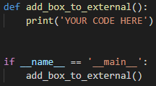

1. Write _add_box_to_external.py and save it in the Blurbs folder.

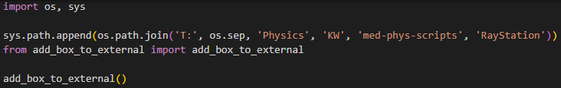

1. Import the blurb into RayStation and name the script Add Box to External.

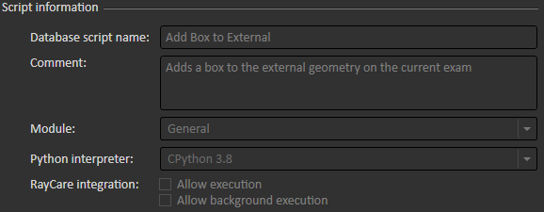

### Testing

The Test^Master patient is meant for, well, testing, including scripts. Their anonymized DICOM files are at [T:\Physics\DICOM Files\Test, Master DICOM](../../DICOM%20Files/Test,%20Master%20DICOM).

When you import a script into RayStation for testing, prefix the script name with *zz* so that users know not to use it. If you need to change a script that users are already using, make a copy and reimport with the *zz*. When you finish making changes, replace the old script file with the new one.

### Constants

According to Python style conventions, constants are defined at the top of a script, below the imports. Constants may also be defined as static variables at the top of a class definition. Please check the values of these constants before implementing a script in RayStation as some are specific to your clinic; where possible, these are above any other constants. When defining your own constants, try not to duplicate constant names across scripts as this could cause naming conflicts when importing functions from scripts.

#### Example

Plan Check uses several constants, defined in the class PlanChkConstants. I did not name this class Constants because I want to avoid name conflicts, and it’s unlikely (and certainly wouldn’t make sense!) that another script would have a PlanChkConstants class.

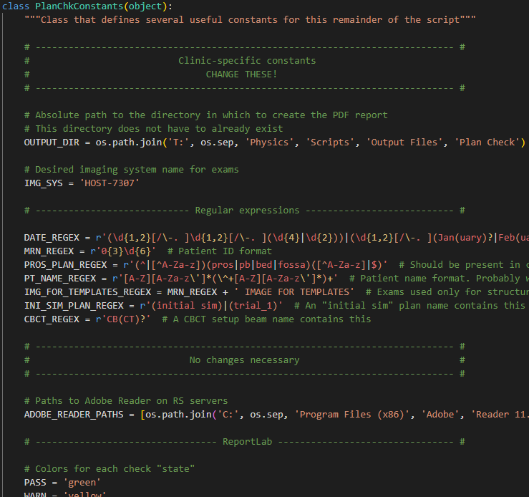

### Code Duplication

As much as it pains me, there is much code duplication across scripts. This is in the attempt to keep scripts as standalone as possible. If the function you need is not the “main” function in its script, copy and paste it.

For example, while writing extend_exam, I realized that I already had name_exam code in copy_exam. But instead of from copy_exam import name_exam, I copied and pasted name_exam from copy_exam into extend_exam.

As another example, the export_dvh_curves script needs a geometry ROI that outlines the dose grid. The dose_grid_box script does exactly this, so export_dvh_curves imports the dose_grid_box function from the dose_grid_box script.

### Parameters

We try not to parameterize “main” functions, so that they can easily be called from the blurb. Parameters are used when we want variations on the same script in RayStation. For example, the copy_exam function takes the parameter with_plans:



The RayStation script Copy Exam calls copy_exam with with_plans=False (the default) while Copy Exam with Plans calls the function with with_plans=True.

Copy Exam: Copy Exam with Plans:

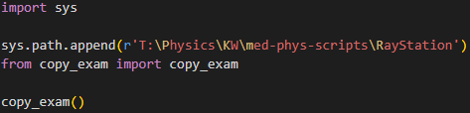 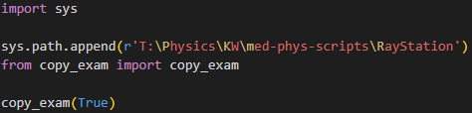

### Comments

Python style [guidelines](https://peps.python.org/pep-0008/#inline-comments) warn against comments that explain what the code does rather than why it does it, but CRMC ignores this recommendation because copious comments really help novice scripters.

### Docstrings

Python style [guidelines](https://peps.python.org/pep-0008/#documentation-strings) recommend against full docstrings for private functions, but CRMC conventionally documents all functions (private, public, helper) and classes. We loosely follow Google’s docstring [style](https://google.github.io/styleguide/pyguide.html).

## Info for End Users

### Script Descriptions

Use the script **Comments** field in RayStation for a summary of what the script does. This should approximately match the first line of the script’s section in this manual. Additionally, any script that saves the patient has *SAVES PATIENT* in its **Comments**. This is important because you cannot undo changes in RayStation that have been saved.

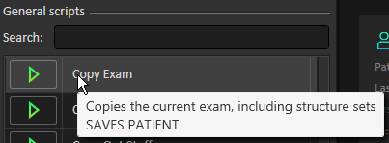

### Scripts You Should Not Use

A script name starts with a single *z* if it is really only useful for scripters. It starts with *zz* if it is currently being tested and is not ready for use.

### Script Validation Message

If the following message appears when you run a script in RayStation, you may ignore it (click **Yes**).

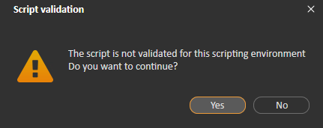

### User Manual Sections

Each script description contains several possible sections:

#### Assumptions

If any of the script’s assumptions are violated, you are prompted to end the script or take some other action. These are not error messages! Here is an example popup from Add Clinical Goals.

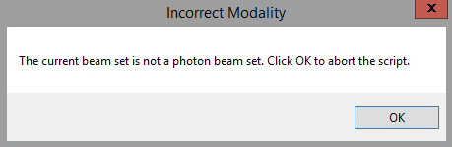

Each script section lists the conditions under which a popup message will appear for violated assumptions.

#### Warnings

At the end of the script, a popup may appear with warnings about what the script could not do. Here is an example warning from Add Clinical Goals. The script was able to finish but could not do everything we wanted it to.

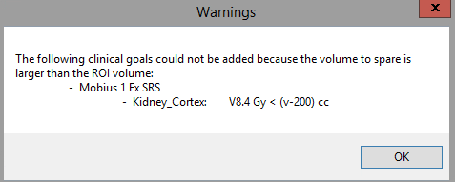

Each script section lists the conditions under which a popup message will appear for warnings.

#### Under the Hood

More technical information about how the script works. This section may be useful for scripters than fpr end users.

#### Example

An example of running the script, will a complete explanation of what the script does.

#### Coming Soon

Enhancements or bug fixes that Kaley would like to implement. End users should add remove, and edit these!

## Add Box to External

Modifies the external (body) geometry on the current exam, to include some of the Vac-Lok™ geometry used for SBRT patients.

SBRT lung patients are positioned using a Vac-Lok™ bag. When planning, we prefer our external geometry to include the body of the patient as well as some area posterior and right/left of the patient. This area ideally encompasses the entire couch geometry in the I-S and R-L directions, and up to the localization point in the P-A direction. In practice, we crop the area by a pixel on each R-L side to prevent possible calculation errors due to the external extending outside the image.

Of course, we want to retain the original external geometry, so before adding the box to it, we copy the external geometry into a new ROI called External^NoBox.

### Assumptions

* A case is open.
* The open case has at least one exam.
* The current exam has an external geometry.
* The external geometry on the current exam is unapproved.
* The couch ROIs exist in the current case.
* The current exam has both couch geometries.
* The current exam has a localization geometry.
* The box geometry (Box), if it exists, is unapproved on the current exam.
* The external geometry without the box (External^NoBox), if it exists, is unapproved on the current exam.

### Example

Here is what the external looks like before running the script; it's just the body:

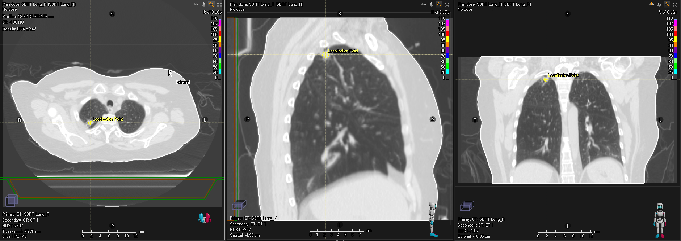

After running the script, we have the modified external:

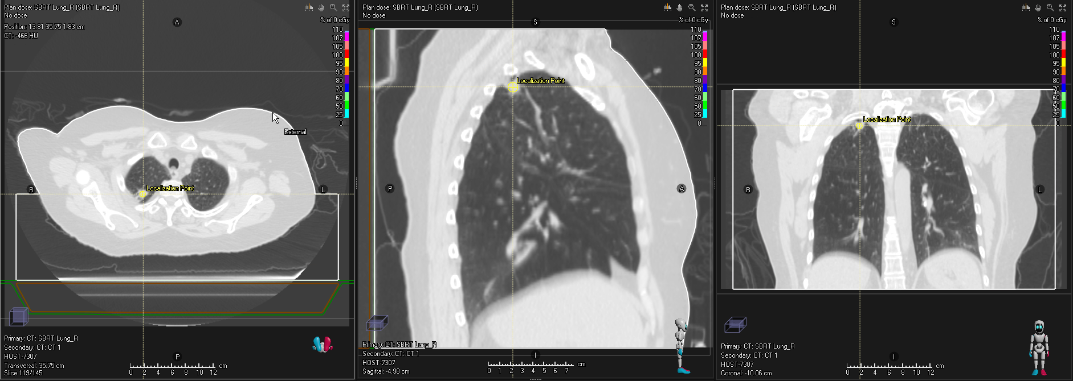

And External^NoBox, containing the original external geometry:

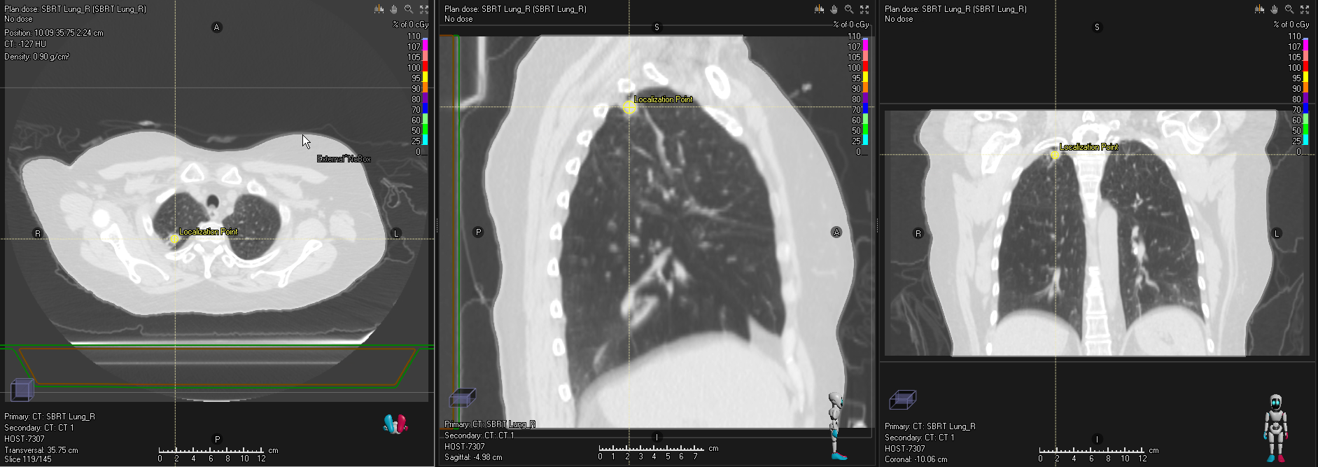

### Coming Soon

* Add the couch if it doesn’t exist.
* Add the external geometry if it doesn’t exist.
* Add new Box and External^NoBox geometries if the existing ones are approved.

## Add Clinical Goals

Adds clinical goals templates from a spreadsheet, to the open plan.

RayStation has clinical goals templates, but they are cumbersome to update. It is easier to keep an updated spreadsheet of clinical goals for various sources/MDs, body sites, treatment techniques, Rx’s, fractionation patterns, etc. We keep this spreadsheet in [T:\Physics\KW\med-phys-spreadsheets](../med-phys-spreadsheets). The priority columns in the spreadsheet are ignored.

Each sheet in the spreadsheet is a clinical goals template. The sheet name is in the following format. Each part is optional.

1. Source (e.g., Dr. J, Chao, or RTOG 0813)
2. Fractionation description (e.g., Conventional) or number (e.g., 1 Fx, 8 or 10 Fx, or 5-6 Fx)
3. Tx technique (e.g., IMRT)
4. Body site(s) (e.g., Pros or Rectum Anus)
5. Rx(s) (e.g., 60 Gy or 70 74 Gy)

Example: Dr. J 5 Fx SRS Brain 30 Gy

Goals in the spreadsheet are written in the following formats. Spacing is ignored.

|  |  |  |  |
| --- | --- | --- | --- |
| **Dose goal** | | | |
| D | __%, __ cc, (v-__ cc), max, min, mean, median | > or < | __% Rx, Rx, Rxp, Rxn, or__ cGy |
| **Volume goal** | | | |
| V | __% Rx, Rx, Rxp, Rxn, or__ cGy | > or < | __%, __ cc, or (v-__ cc) |

ROI names in the spreadsheet are TG-263 compliant. ROI names in RayStation are matched if:

* They match exactly
* They match with an _L or _R suffix
* They match with some “extra” information: ^ plus the info
* They match with a copy number in parentheses
* The ROI in the spreadsheet is “general,” and the ROI in RayStation is in the list of “specific” ROIs listed at the top of the script for that “general” ROI, accounting for the above rules

For example, a goal for Lung is applied to Lung, Lung_L, Lung^Adapt, Lung (2), etc.

TG-263 PRV names do *not* match a spreadsheet ROI name that is not a PRV. A PRV ROI in the spreadsheet that does not include an expansion matches any PRV ROI in RayStation. For example, a goal for Lens_PRV is applied to Lens_PRV, Lens_PRV03, etc.

The Notes column in the spreadsheet can be anything, but the script uses the following types of notes (case insensitive):

* __ Gy. Only apply the goal if the Rx matches.
* __ fx. Only apply if the Rx fractionation matches.
* Ipsilateral or contralateral (case insensitive): For goals to paired organs, the side of the organ that the goal is for. The left organ is to the left of the Rx side, the right organ to the right. The “center” of the Rx is determined by:
  + If the Rx is to a target, the center of the target geometry
  + If the Rx is to a DSP, the DSP coordinates
  + If the Rx is to a site that is not a DSP, the coordinate of max dose
  + Otherwise, the coordinates of the initial laser isocenter if it exists

The following goals cannot be added. You are warned of any of these goals before the script exits

* Goals that do not match the above formats
* Volume-to-spare goals for which geometries are empty
* Volume-to-spare goals for which the volume to spare is larger than the geometry volume
* Ipsilateral/contralateral goals for which the Rx side could not be determined
* Goals for a nodal PTV, but there is no nodal PTV

If the plan is approved, you may add goals to a copy of the plan.

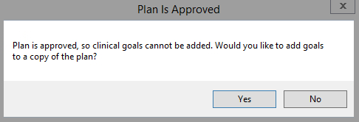

See Copy Plan without Changes for details on how the copy is created.

In addition to the template goals, the script adds the following goals:

* If there is a prescription and the exam has an external geometry, add a Dmax (D0.03 cc) goal to the external. For SABR plans (including SBRT, SRT, and SRS), this is 125 percent of the primary prescription. For non-SABR plans, it is 110 percent.
* For each prescription to a PTV, add D95% ≥ Rx, V95% Rx ≥ 100%, D100% ≥ 95%, and VRx ≥ 95% goals to the PTV. If the PTV is derived, add D100% ≥ Rx and VRx ≥ 100% goals to each CTV in the PTV’s derived expression.

The **Priority** column in the clinical goals display in RayStation tells which template a goal comes from. The templates are applied in alphabetical order. If a goal is in multiple templates, the priority is the first template that includes it. A key for these numbers is added to the plan comments. Goals that are not part of a template (see Other Goals above) have no visualization priority. Existing goals’ priorities are unchanged.

### Assumptions

* A patient is open.
* A case is open.
* A plan is open.
* The open plan has at least one beam set.
* The current beam set’s modality is photons.
* The current beam set’s machine is commissioned.

### Example

Here, we add two clinical goals templates to an SBRT lung plan: RTOG 0813’s and Mobius3D’s.

1. The script launches with the following window:
   1. By default, the existing goals in a plan are deleted and replaced with the ones from the selected templates.
   2. The script selects the appropriate Mobius3D script based on the plan’s treatment technique and fractionation.

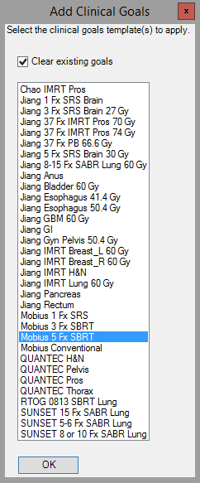

2

1

1. Select the templates that you want to apply. These may include the default selection but don’t have to. You can select multiple templates using Ctrl+Click and Shift+Click.

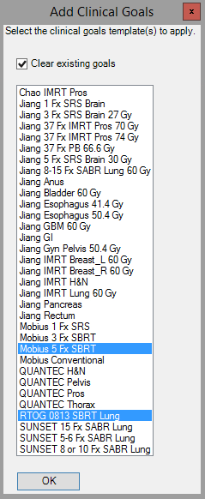

1. The goals for ROIs that exist in the current case are applied:

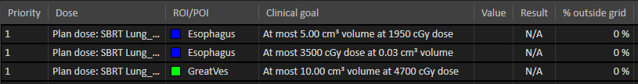

⋮



⋮

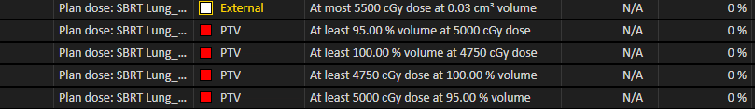

The plan comments:

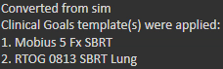

### Coming Soon

* Allow user to select which notes from the selected templates apply.
* Disable and uncheck the **Clear existing goals** checkbox if there are no goals in the current plan.
* Make the visualization priorities unique.
* Add Jiang 3-5 Fx SRS Brain and others.
* Add tab for objectives/constraints templates.

## Add Couch

Adds template couch structures at the correct location on the current exam.

The Elekta Couch template is applied for supine patients, the Elekta Prone Couch template for prone. The correct location is the R-L center and I-S center and at the top of the sim couch in the P-A direction.

The sim couch location is determined using the exam’s pixel intensities. The below graph shows the y-axis intensities of an example CT. We select all peaks meeting certain height and prominence criteria (determined via trial and error). The last (most posterior) of these corresponds to the bottom of the sim couch.

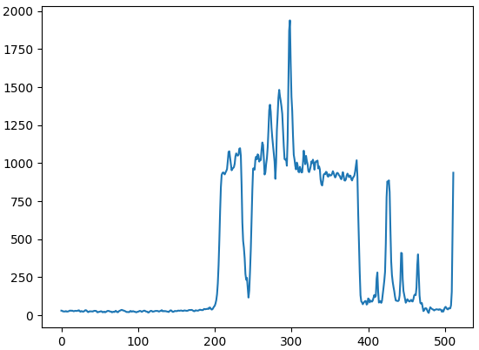 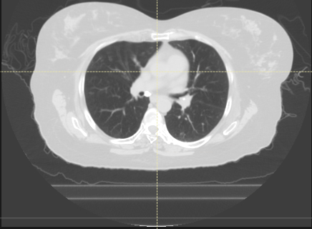

2.5 cm

The coordinate of the peak is then converted to an exam coordinate and moved 2.25 cm anteriorly to the top of the sim couch instead of the bottom. The couch structures are then added with centers at the P-A center of the sim couch.

The default dose grid encompasses all geometries. The script sets the default dose grid for any unapproved plans on the current exam that are not initial sim plans. (An initial sim plan is named Trial 1, Trial_1, Initial Sim, etc. [case insensitive]).

Adding the couch invalidates any computed dose, so the script re-computes the dose on any unapproved beam sets.

### Assumptions

* A patient is open.
* A case is open.
* The current case has at least one exam.
* The patient position of the current exam is HFS, HFP, or FFS.
* Neither couch geometry, if it exists, is approved on the current exam.

### Warnings

The correct P-A coordinate could not be determined, so you must manually adjust the couch positions after the script finishes. You may run Center Couch to correct any R-L error that manual adjustment may have introduced.

### Example

Before running script, there are no couch geometries, but the script would also work if the geometries existed but were unapproved.

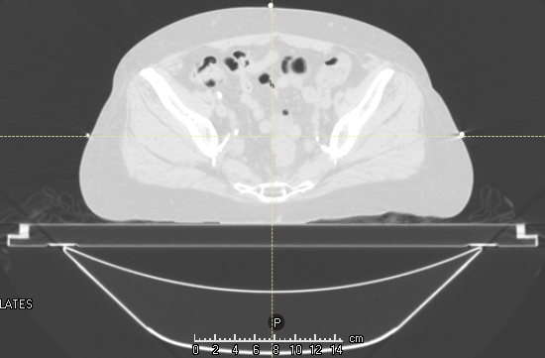

After running script, the couch geometries are in the correct location.

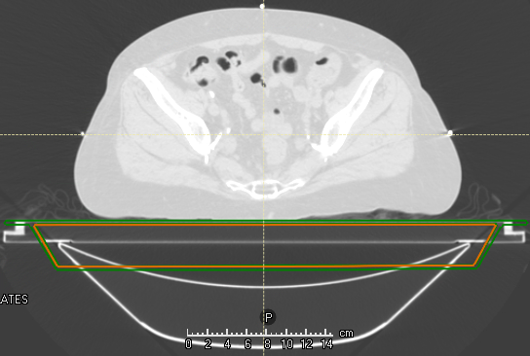

## Center Couch

Centers all couch geometries on the current exam.

Checks all couch names in the Elekta couch structure templates (Elekta Couch and Elekta Prone Couch) and centers existing couch geometries that are unapproved and nonempty on the current exam.

### Assumptions

* A case is open.
* The open case contains at least one exam.

### Warnings

* Certain geometries could not be centered because they are approved or empty.

Examples

The Add Couch script doesn’t always perform well on Tomo sims because the couch isn’t usually added for Tomo plans. Add Couch gives this warning if the top of the sim couch could not be found and thus the couch could not be correctly positioned:

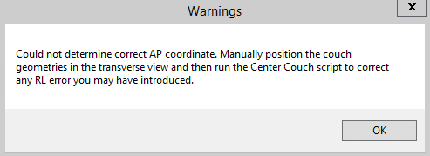

Obviously, the couch is too anterior:

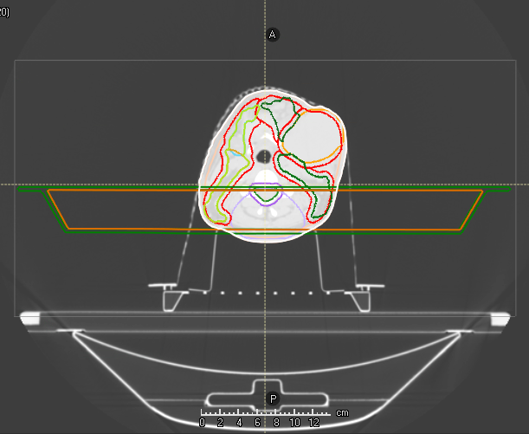

After manually adjusting the couch position by Ctrl+clicking the two couch ROIs and using the Translate tool, we may have accidentally moved the couch a little in the R-L direction:

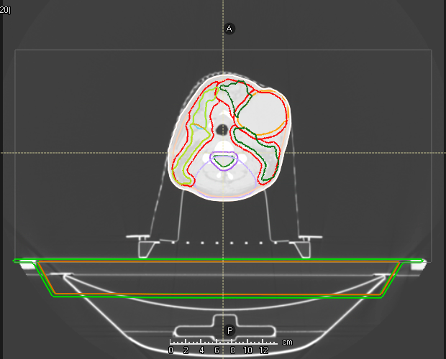

Run Center Couch to reset the RL coordinate to zero:

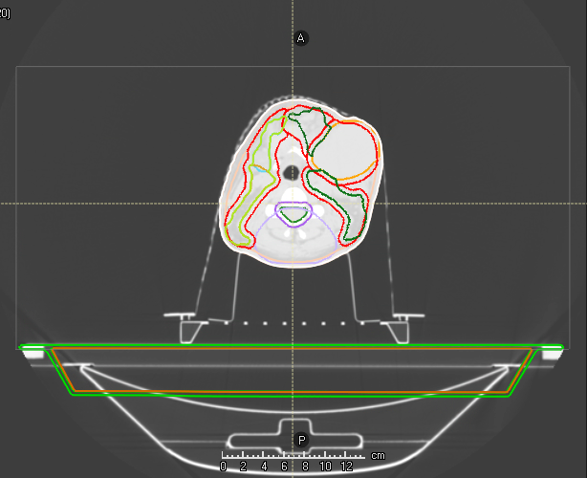

## Center Geometries

Centers ROI geometries in the R-L, A-P, and/or I-S directions on the current exam.

Choose the ROIs and directions from a GUI. Only non-empty, unapproved geometries on the current exam are available to center. The ROIs in the GUI are listed in case-insensitive alphabetical order.

### Assumptions

* A case is open.
* The open case contains at least one exam.
* The current exam contains at least one non-empty, unapproved ROI geometry.

### Example

The Add Couch script occasionally places the couch in the incorrect A-P location. When the user manually corrects this, it is easy to accidentally un-center the couch in the R-L direction. The Center Geometries script can re-center the couch.

1. Before running Center Geometries, the couch structures are clearly off center in the R-L direction.

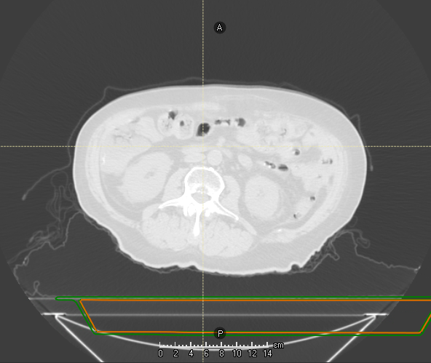

1. Run the script. Check the R-L direction for the two couch structures and click **OK**. Note that the **OK** button is disabled if no checkboxes are checked.

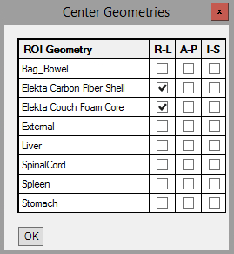

1. After running the script, the couch structures are in the R-L center.

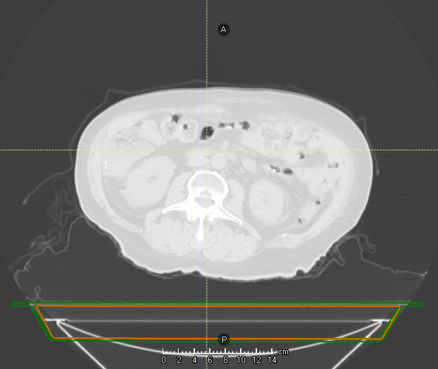

### Coming Soon

* Center POIs in addition to ROIs.
* If the geometry is approved, offer to center a copy of the structure.

## Contour Chestwall

Contours Chestwall_L and Chestwall_R geometries using ROI algebra of lung geometries.

The chestwall is the difference of the anteriorly, posteriorly, and ipsilaterally expanded ipsilateral lung, and the ipsilaterally expanded contralateral lung, using the expansion LUNG_EXPANSION_FOR_CHESTWALL specified at the top of the script. In this example, it is 3 cm.

Chestwall_L:

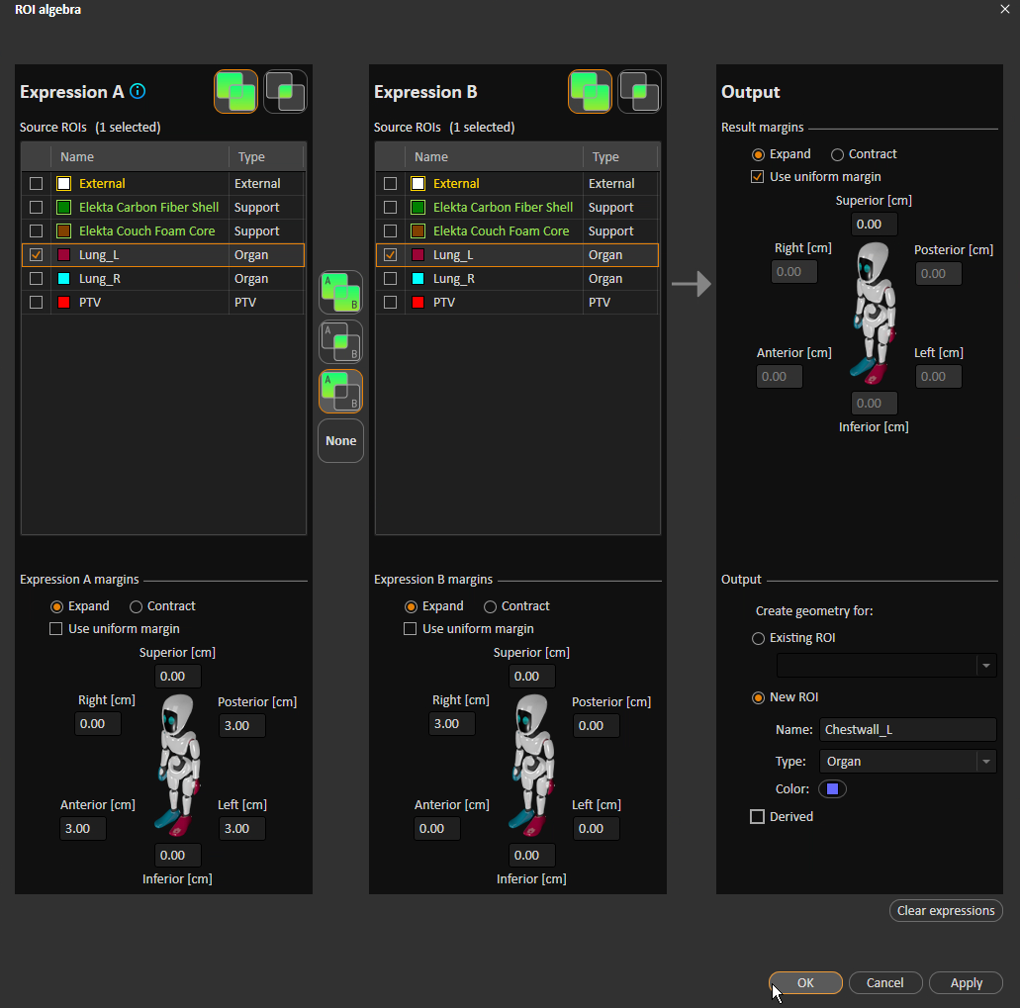

**R expansion**

**P, A, & L expansion**

**Subtraction**

**Ipsilateral lung**

Chestwall_R:

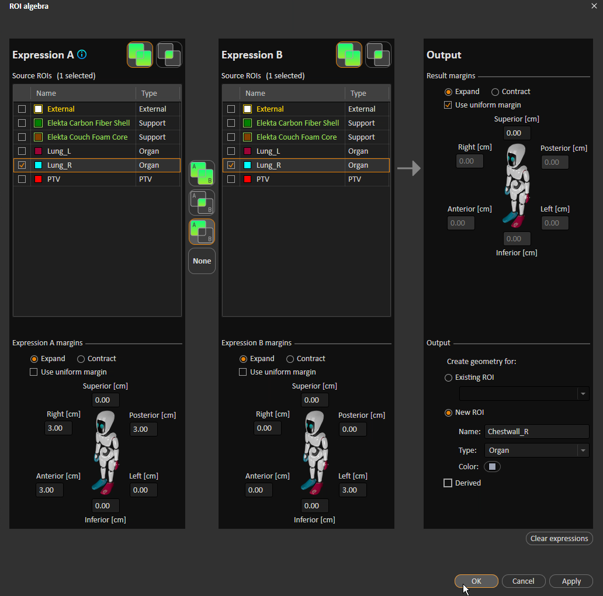

**Ipsilateral lung**

**Subtraction**

**P, A, & R expansion**

**L expansion**

Crops chestwall geometries to the external geometry.

If both chestwall geometries are successfully added, removes overlap by subtracting a random one of them from the other.

### Assumptions

* A case is open.
* The current case has at least one exam.
* The current case has an external ROI.

### Warnings

* A chestwall geometry could not be added due to a missing lung geometry.
* A chestwall geometry already exists and is approved.

### Example

Before running the script:

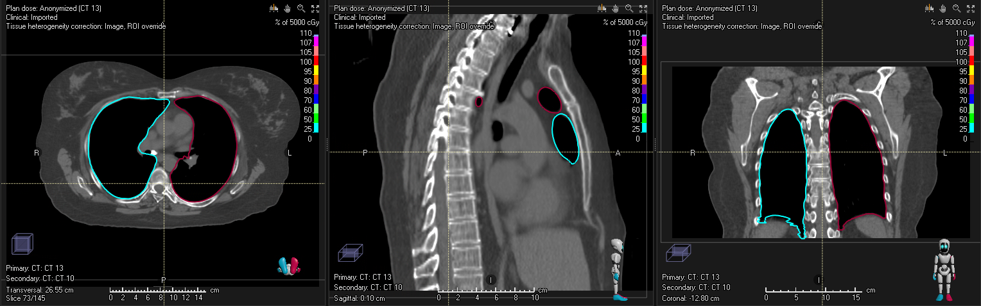

After running the script:

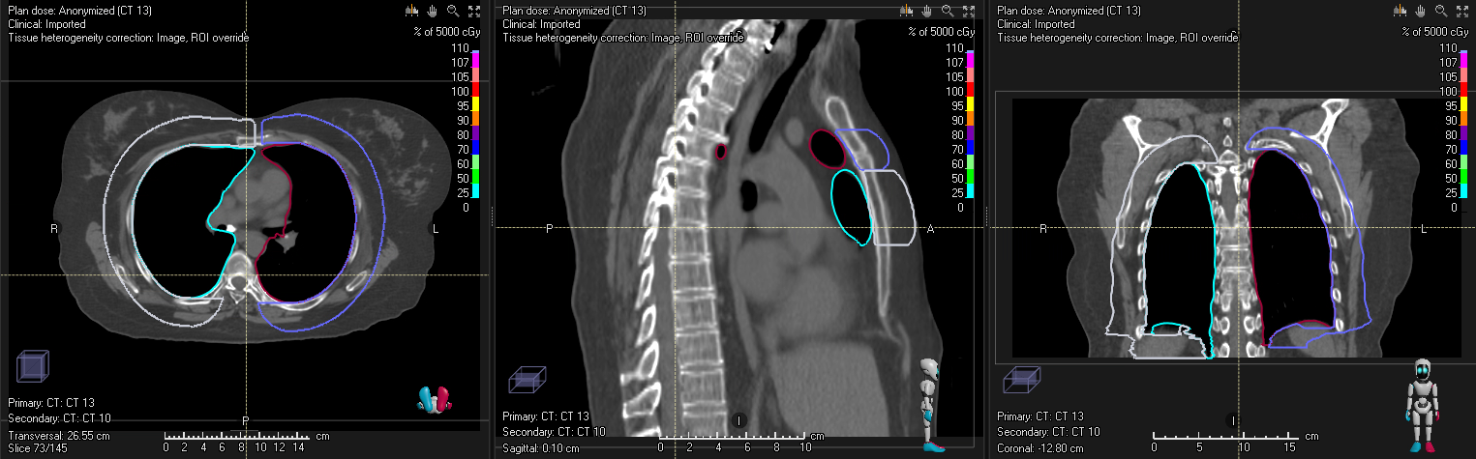

Some cleanup in the inferior direction is obviously necessary.

### Coming Soon

* Add external ROI if it doesn’t exist.
* Add external geometry if it is empty.
* Create Chestwall as the sum of Chestwall_L and Chestwall_R.

## Compare Contours

Copies ROI geometries from selected exam(s) to another exam to enable geometry comparison across exams.

### Assumptions

* A case is open.
* The open case has at least one exam.
* At least one exam in the open case has geometries that are not external, support, or fixation.

### Example

We compare the geometries across three exams

* Orig Contours: Dosimetry’s contours
* ABS Contours: Contours created with the HFS abdomen atlas
* MBS Contours: Contours created using model-based segmentation

The script allows the user to choose the exam(s) to copy geometries from, and the exam to copy contours to. If the current exam has contours, it is by default selected to copy to. Otherwise, no exam is selected. By default, the first row is selected to copy from.

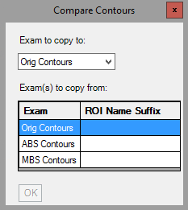

Note that the **OK** button is grayed out. It is enabled only if (a) an exam is selected to copy to, (b) at least one exam is selected to copy from, (c) a suffix is provided for each selected exam to copy from, and (d) each suffix is unique.

We want to copy geometries from both ABS Contours and MBS Contours to Orig Contours, so we slect those two rows. I’ll add an appropriate suffix for each.

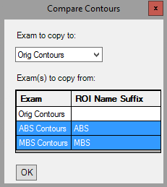

When I click **OK**, the script will create a new ROI for each geometry on ABS Contours. The new ROI name is the same as the old one, plus the suffix according to TG-263 (suffix comes after a carat). For example, if ABS Contours has an ROI called Kidneys, the script creates Kidneys^ABS. The Kidneys geometry is copied into Kidneys^ABS, the Kidneys^ABS geometry is copied from ABS Contours to Orig Contours, and the Kidneys^ABS geometry is deleted from ABS Contours. This process is repeated for each MBS Contours geometry.

Suppose that before running the script, Orig Contours had two geometries, Kidneys and Liver; ABS Contours had a single geometry, Kidneys; and MBS Contours had two geometries, Kidneys and Bag_Bowel. After running the script, there will be three new ROIs: Kidneys^ABS, Kidneys^MBS, and Bag_Bowel^MBS, each of which only has contours on Orig Contours.

In the below screenshot of Orig Contours, all geometries are hidden except for Kidneys, Kidneys^ABS, and Kidneys^MBS. We can now easily evaluate the differences among the three geometries.

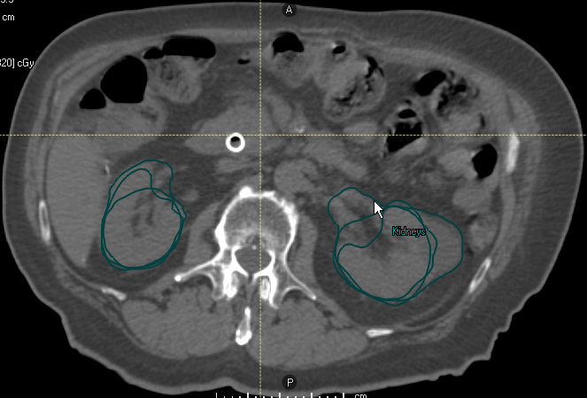

You can copy from an exam to itself. Suppose the same conditions as above, but instead of copying from ABS Contours or MBS Contours, I copy from Orig Contours. After running the script, each Orig Contours contour will simply be copied into a new ROI with the suffix Copy.

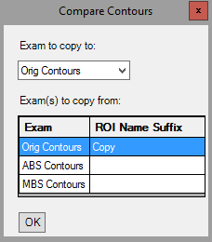

## Convert Virtual Jaw to MLC

Converts virtual jaw fields from external simulation (no MLCs) fields into jaw- and MLC-defined fields.

This script is modified from one provided by RaySearch support. My version supports RayStation 11A and multiple beam sets. A use case for this beam set is converting plans sent to RayStation from sim, into “Initial Sim” plans.

For each beam set in the open plan whose machine is not SBRT 6MV or ELEKTA (CRMC’s two clinical machines as defined in RayStation), a new, single-fraction, conformal beam set is created with the localization point as isocenter and the same exam and patient position as the old beam set. Its beams have the same isocenter (name has a 1 added to the end), beam quality, name, description, gantry and collimator angles, and couch parameters as the old beams. Each new beam has a rectangular field with the same jaw positions as the old beams.

The new beam set’s machine is SBRT 6MV if any of the exams in the case have AVG, MIP, or Gated in their SeriesDescription DICOM attributes. The machine is ELEKTA otherwise.

The new setup beam names are changed to match their descriptions.

The old beam sets are deleted.

### Assumptions

* A patient is open.
* A case is open.
* A plan is open.
* All sim beam sets are photons.

### Example

Before running script, we have a plan that we imported from sim:

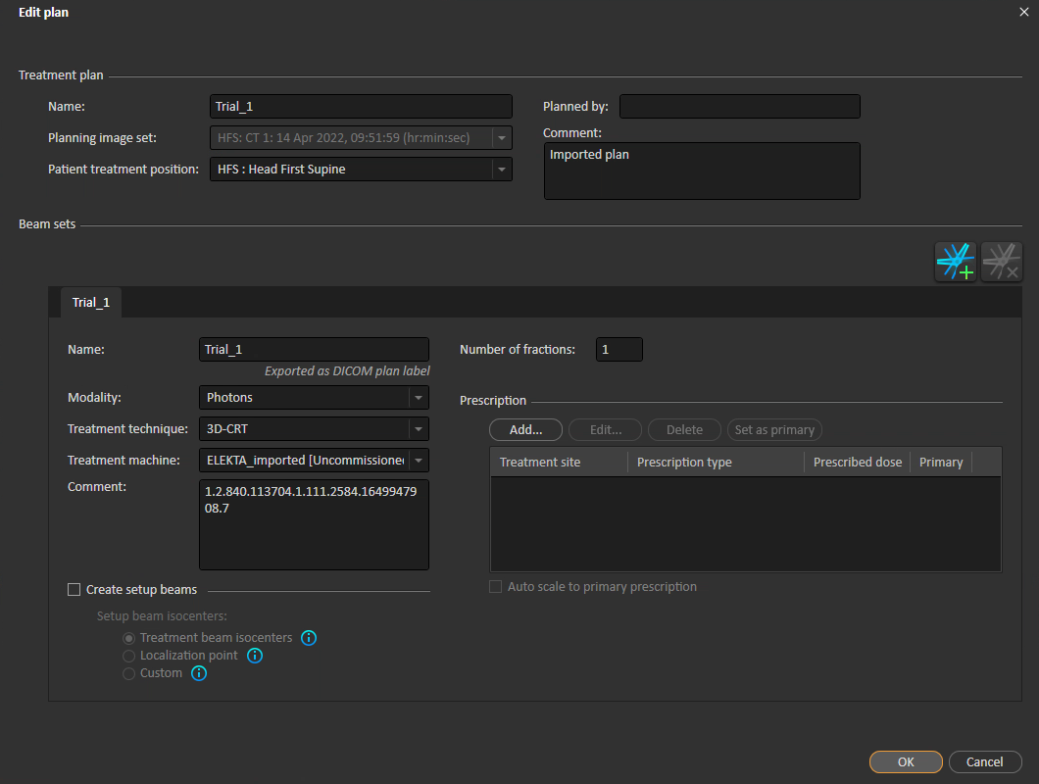

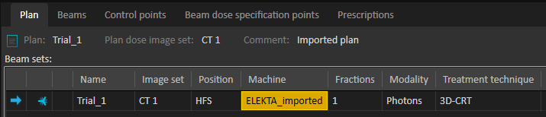

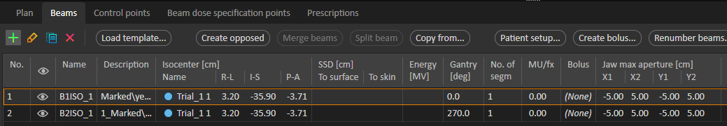

After running the script, note the differences between the plan from the sim, and the converted plan.

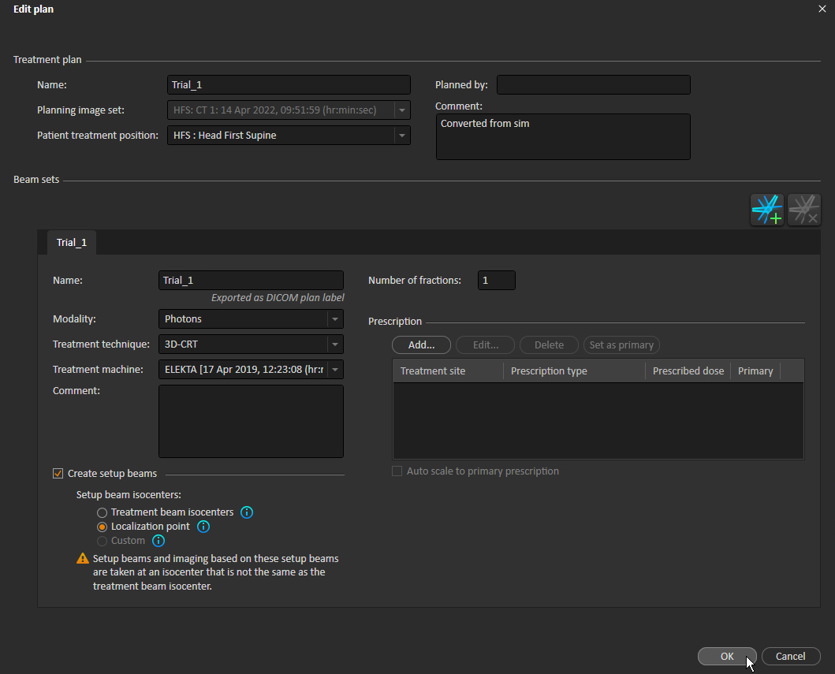

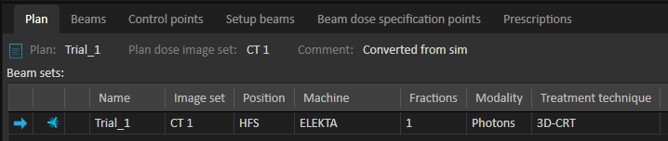

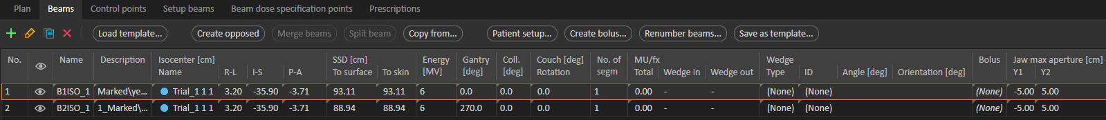

## Copy Beam Set

Copies the current beam set. Supports imported doses.

Objectives and constraints, select optimization parameters, and prescriptions are also copied. See Copy Opt Stuff for an explanation of how objectives, constraints, and optimization parameters are copied.

If the current plan is approved, the script offers to copy to a copy of the plan. See Copy Plan without Changes for details on how the plan is copied.

The new beam set has the same name as the old, made unique across all beam sets in all cases in the current patient. The new beam set name is truncated to 16 characters due to DICOM-imposed length limitations.

Consider an old beam set called SBRT Lung. If the patient’s other beam sets are 3D Lung_R and Beam set 1, then the new beam set will be SBRT Lung (1). If SBRT Lung (1) already existed, the new beam set would be SBRT Lung (2). If the old beam set had a long name like Really Long Name and needed to be named Really Long Name (2), the new name would be truncated to Really Long (2) to meet length constraints.

Beam names are treated similarly.

Beam numbers are unique across all the patient’s beams and setup beams. The new beam numbers start with a number one greater than the maximum beam or setup beam number in the patient, and continue consecutively from there. New setup beams continue consecutively after the new beams.

### Assumptions

* A patient is open.
* A plan is open.
* The open plan has at least one beam set.
* The current beam set is either photons or electrons.

### Example

Copy the beam set 3D Lung_R in the plan 3D Lung_R. This beam set looks like this:

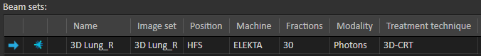

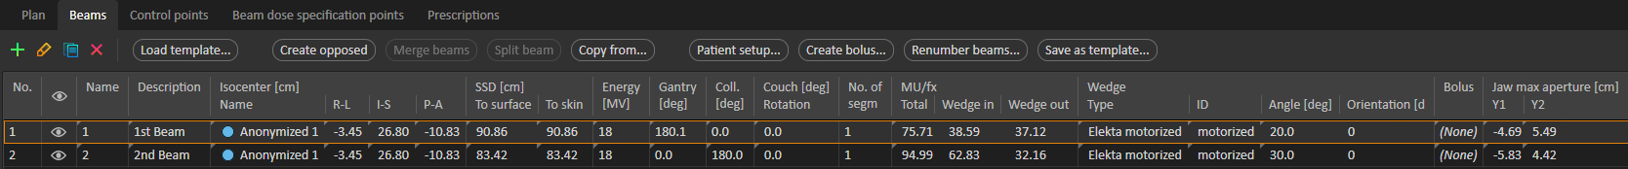

After running the script, we have two beam sets.

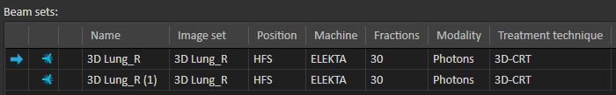

The beams look like this:

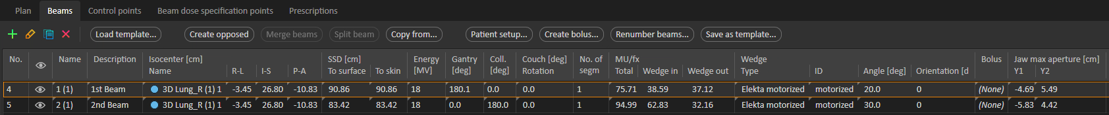

## Copy Exam

Copies the current exam, including all structure sets on the exam. All structure sets on the new exam are unapproved.

The new exam is part of a new study and new series.

Derived ROIs are updated on the new exam only if they are up to date on the old exam.

The imaging system (if available) and level/window preset are also copied.

### Assumptions

* A patient is open.
* A case is open.
* The open case has at least one exam.
* The exam to copy is a CT exam.

The new exam name is the same as the old name, possibly with a copy number to maintain uniqueness. For example, if the case contains exams Exam A, Exam A (2), and An Exam, and we copy Exam A, the new exam name will be Exam A (3).

An exam is uniquely identified by its Series Instance UID DICOM attribute, so two exams in the same case cannot have the same Series Instance UID. Therefore, the copied exam has a different Series Instance UID than the original.

The Study Instance UID is also changed because it would not make sense for a copy to be part of an existing study. For instance, suppose we copy a phase of a 10-phase gated study. If the copy had the same study UID as the original, RayStation would now think the study had 11 phases!

### Under the Hood

The script works by exporting the current exam’s DICOM to a temporary directory, changing UIDs and filenames (the filename contains one of the UIDs) for all exported DICOM files, and reimporting the “new” study. The temporary directory is then deleted. A new UID is computed by incrementing the last “part” of the old UID. For example, if the old UID is 2.4.6.8, the new UID is 2.4.6.9. The changed UIDs are Study Instance UID (same across all slices), Series Instance UID (same across all slices), and SOP Instance UID (unique per slice).

### Example

Let’s copy exam 3D Lung_R. Note the two derived ROIs: SpinalCord_PRV05 is up to date while Lungs-PTV is not.

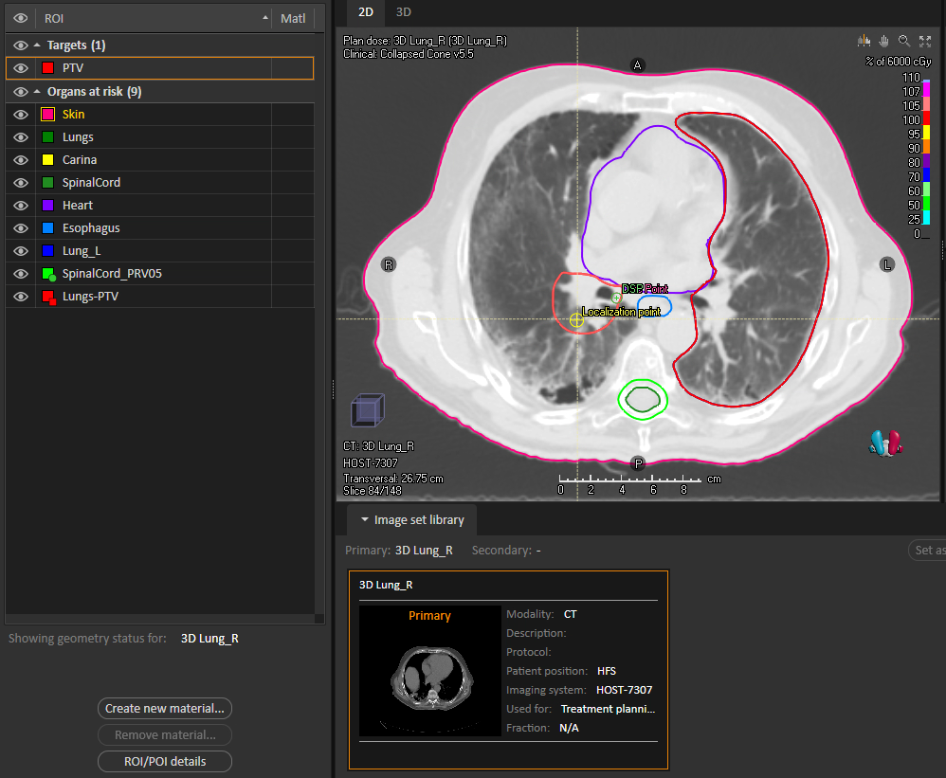

**Updated derived geometry**

**Dirty derived geometry**

**Old exam name**

After running the script, there is a new exam called 3D Lung_R – Copy with the same geometries as 3D Lung_R. The SpinalCord_PRV05 geometry has been updated, but the Lungs-PTV geometry has been overridden because it is dirty on the old exam.

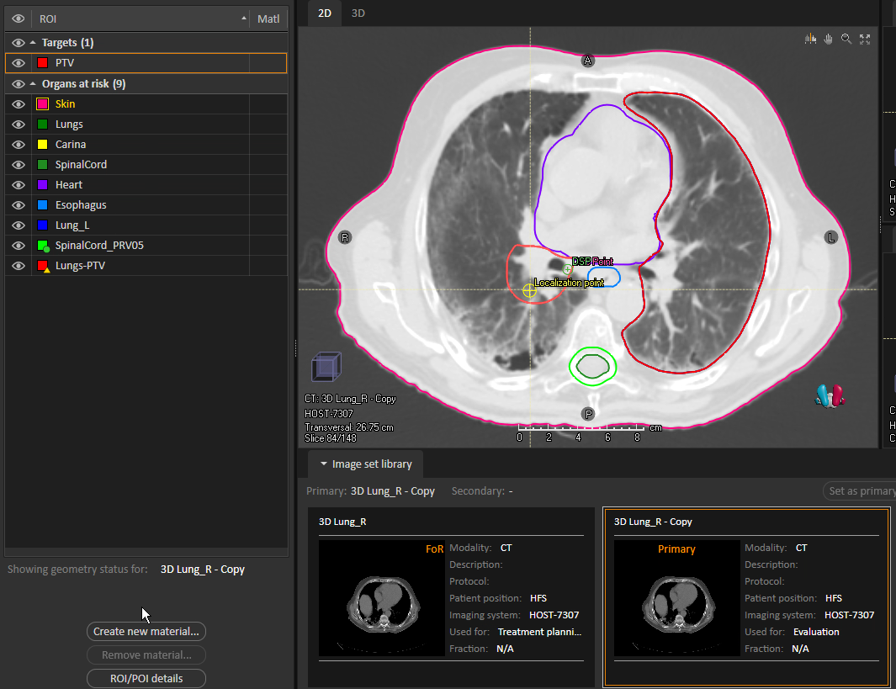

**New exam name**

**Updated derived geometry**

**Overridden derived geometry**

## Copy Exam with Plans

Copies the current exam, including all structure sets and non-imported beam sets with dose. All new structure sets and plans are unapproved.

Same as Copy Exam, but also copies any beam sets on the copied exam that do not have imported dose and that do have final dose computed. The physical, not effective, dose is copied.

The new plan names are the same as the old plan names, made unique but truncated to 16 characters. The new beam set names, numbers, and descriptions (including setup beams), clinical goals, objectives and constraints, optimization parameters, and prescriptions are also copied. The new plan comments are “<new plan name>” on “<new exam name>”, appended to the old plan comments if they exist.

In some cases, the script creates “temporary” plans. It is not possible to delete plans via script, so at the end of the script, the user is prompted to delete any temporary plans.

### Assumptions

* A patient is open.
* A case is open.
* The open case has at least one exam.
* The exam to copy is a CT exam.

### Under the Hood

RayStation is unique in its concept of “beam sets”: each beam set is exported to its own RTPLAN DICOM file. For a plan containing multiple beam sets, after all RTPLANs are imported, the beam sets in each are combined into the single plan.

Because the exported DICOM files are related via several “Referenced UID” attributes, several attribute values are changed in the exported DICOM before re-import! The following DICOM attributes are edited:

* For all DICOM files:
  + SOP Instance UID: Unique identifier for DICOM file
  + Media Storage SOP Instance UID: Same value as SOP Instance UID
  + Study Instance UID: Same across all DICOM files
* For CT DICOM files (one for each slice):
  + Series Instance UID: Same across all CT DICOM files
* For RTSTRUCT DICOM files:
  + Series Description: RS: Unapproved to unapprove the structure set
  + Structure Set Label: RS: Unapproved to unapprove the structure set
  + Approval Status: UNAPPROVED to unapprove the structure set
  + Series Instance UID: The SOP Instance UID plus a short suffix
  + Referenced SOP Instance UIDs of contour images
* For RTPLAN DICOM files:
  + Series Instance UID: The SOP Instance UID plus a short suffix
  + Approval Status: UNAPPROVED to unapprove the plan
  + RT Plan Name: Name of the plan that the beam set belongs to. Same as the old plan name, made unique among all old and new plans in the current case.
  + Referenced SOP Instance UID for the associated structure set
* For RTDOSE DICOM files:
  + Referenced SOP Instance UID for the associated RTPLAN (beam set)
  + Series Instance UID: For plan (beam set) doses (Dose Summation Type of PLAN), the SOP Instance UID plus a short suffix. For beam doses (Dose Summation Type of BEAM), the Referenced SOP Instance UID plus a short suffix.

### Example

This script was originally created when the Plan Check script found missing couch structures in an approved plan. Our couch structures have material density defined, so they cannot be added to exams that are part of approved plans. Specifically, the Add Couch script tells us this:

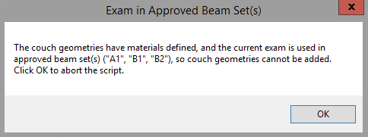

The solution is to copy the exam and plan, unapprove the copy plan, and then add the couch to the copy plan.

Here is how to use the script to resolve this issue for two approved plans, Plan A and Plan B, on exam Exam. Plan A consists of a single single-beam beam set, A1. Plan B contains two beam sets: B1, with a single beam, and B2, with two beams.

Plan A:

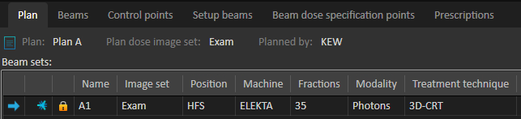



Plan B:

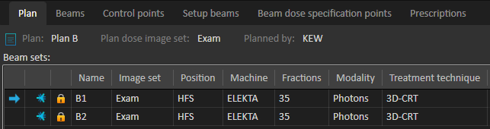



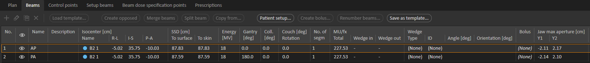

As discussed in Under the Hood, each beam set is exported as its own plan. Since Plan B has two beam sets, the second one is imported as the new plan name with the _1 suffix:

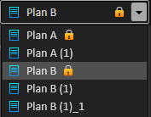

This plan’s beam set is copied into Plan B (1) (the new plan with Plan B’s first beam set), and you are prompted to delete Plan B (1)_1.

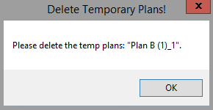

Plan A (1) and Plan B (1) exactly match Plan A and Plan B, respectively, except that the former have imported dose.

Plan A (1):

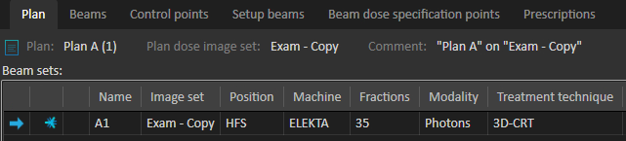



Plan B (1):

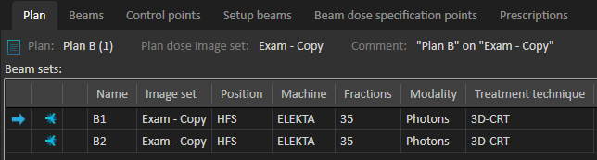



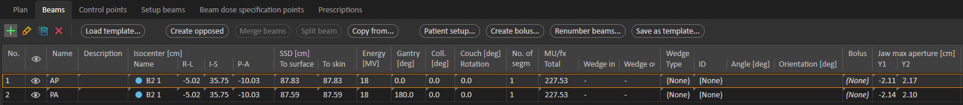

These new plans are unapproved and on a copy of Exam:

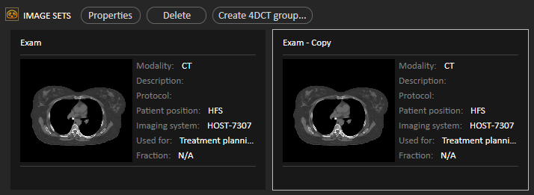

## Copy Opt Stuff

Copies clinical goals, objectives and constraints, and/or optimization parameters from other plans to the current plan.

If the plan to copy to is approved, the script offers to copy to a copy of the plan. See Copy Plan without Changes for details on how the plan is copied.

### Assumptions

* A patient is open.
* A case is open.
* There is at least one plan in the current case.
* There are at least two plans in the current case.

### Example

The script launches this window:

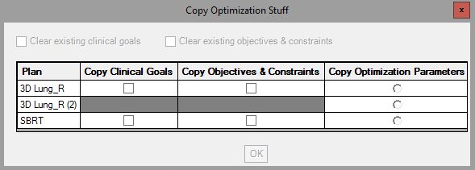

The checkboxes at the top are disabled if the current plan has no goals or objectives/constraints, respectively.

The table allows you to select no, one, or multiple plans from which to copy goals; no, one, or multiple plans from which to copy objectives/constraints; and no or one plan from which to copy optimization parameters. Gray cells indicate plans that don’t have any goals or objectives/constraints. For example, 3D Lung_R (2) has neither goals nor objectives/constraints.

The **OK** button is enabled only if at least one checkbox or radio button is selected.

The below selections copy the following to the current plan:

* Clinical goals from 3D Lung_R and SBRT
* Objectives and constraints from SBRT
* Optimization parameters from 3D Lung_R (2)

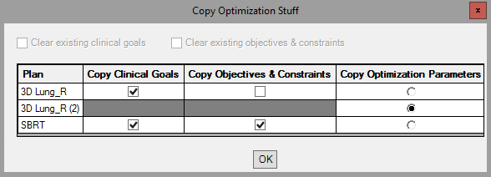

### Coming Soon

* Support for multi-beam set plans. Currently, script assumes, without warning the user, that the current plan (to copy to) and each plan to copy from contains just one beam set.
* Don’t add duplicate objectives and constraints.
* Add visualization priority to copied clinical goals so the user can see which plan each goal comes from.

## Copy Plan to New CT or Merge Beam Sets

Copies a photon or electron plan to another exam or merges beam sets for plans on the same exam. The new exam must have an external geometry. I modified this script from one provided by RaySearch support. My version works with RayStation 11A and CPython and better adheres to programming best practices and Python style guidelines.

The script presents two tabs:

* **Copy Plan To New CT**

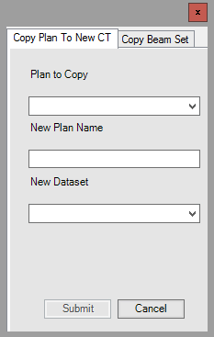

* **Copy Beam Set**

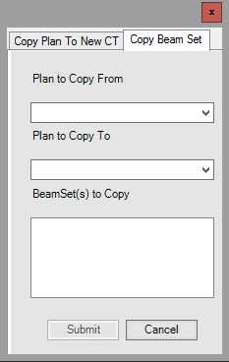

The “copying” is less comprehensive than we’d prefer, but this script is the closest that RaySearch could provide. The problem is that we can’t directly copy control points. We must first optimize. But only IMRT plans need optimization. Even for IMRT plans, since optimization is stochastic, we can’t expect to copy the old beam set’s goals, objectives and constraints, and optimization parameters to the new beam set and get the same results. Therefore, before manually copying the control points from the old beam set to the new, the script performs a dummy optimization with a dummy PTV. There is a single objective based on the beam set’s primary prescription:



Another problem is that structures are not copied to the new exam.

### Assumptions

* A patient is open.
* A case is open.
* If copying (as opposed to merging):
  + There is an external geometry on the planning exam of the plan that is being copied.
  + The plan to be copied has dose.
  + The exam of the plan to be copied, and the exam to copy the plan to, are registered.

### Warnings

* Beam sets that could not be copied/merged because they are neither electrons nor photons

### Under the Hood

1. If copying plan, create a new plan on the new CT. The new plan name is the same as the old, with a copy number for uniqueness.
2. For each old beam set, add a new beam set in the plan that we are copying to. The new beam set names are the same as the old beam set names, with a copy number for uniqueness within the case. The new beam set comments are From <old beam set>, where <old beam set> is the old beam set name. The new beam set has the default dose with the same voxel size as the old dose grid.
3. For each new beam set, add the beams. If copying a plan, the new isocenters are registered between the old and new planning exams. For all beams, beam quality, name, gantry and couch angles match.
   1. For electron beams, the applicator angle and name, insert name and contour, and MU also match.
   2. For non-VMAT photon beams, the collimator angle also matches, and each segment is copied by adding a rectangular field with the same leaf and jaw positions, MU, and relative weight as the old segment.
   3. For VMAT beams, the end gantry angle and arc direction also match. Control points cannot be manually created, so they are added via a dummy optimization. A dummy sphere PTV with radius 2 cm and center at the isocenter has a single optimization objective: uniform dose (the beam set’s primary prescription) with weight 90. The optimization has no preparatory iterations and a single optimization iteration. The beams have the same final arc gantry spacing optimization parameter as the old beams. After the dummy optimization, the beam MU is copied, and control points are copied by copying each segment leaf and jaw positions, dose rate, and relative weight.
4. Compute each new photon beam set. For each new electron beam set, alert the user that histories and prescription must be set before computing dose.

### Example

Here, we copy the plan SBRT RLL from the exam AVE 3-23-22 PLAN HERE to the exam AVE 3-23-22 created in RS.

The old plan:

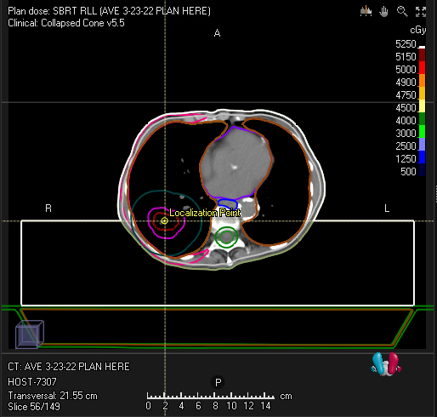

Set the appropriate values in the script:

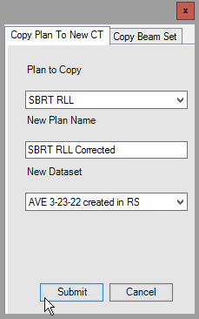

A new plan called SBRT RLL Corrected will be created on the exam AVE 3-23-22 created in RS.

### Coming Soon

* For copying plans, register the old and new planning exams if a registration does not exist.

## Copy Plan without Changes

Copies the current plan, retaining beam set and isocenter names.

RayStation's **Copy plan** functionality is amazing, but we wanted to change a couple of naming conventions in the copy:

* Retain beam set and isocenter names.
* The beam sets and beam isocenters in the copied plan have the same name as the plan, plus a copy number. For example, if a plan called R Breast with two beam sets is copied to a plan called R Breast (1), the new beam sets are called R Breast (1) and R Breast (1)_2 respectively, regardless of their names in R Breast. Likewise, the beam isocenters are called R Breast (1) 1 and R Breast (1).
* Renumber the new beams.

We make the new beam numbers unique among all beam numbers in the patient. The first beam is numbered one more than the greatest beam number in the patient, and beam numbers increase consecutively from there.

* Name beams the same as their numbers.

We want to retain any important information from the old name, though, so if an old beam name is different from its number (or a setup beam name is not the default), we append the old name to the new description.

The new plan name is the same as the old plan name plus a copy number (e.g., R Breast (1)).

### Example

Given a plan Plan 1:

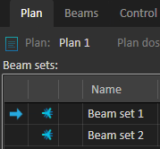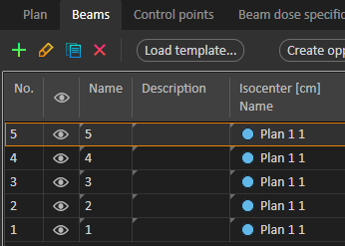

If we copy Plan 1 using the **Copy plan** button, naming the copy Plan 1 (1), we get these names and numbers:

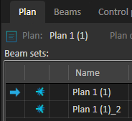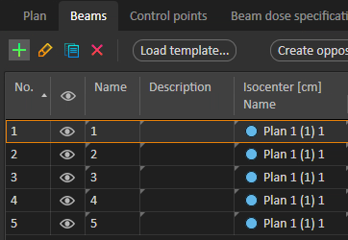

If we instead copy the plan using the script, the Plan 1 (1) beam sets and beams match those in Plan 1 and are uniquely numbered:

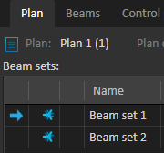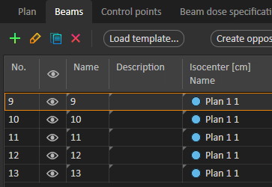

## Create QA Plan

Creates and exports a DQA plan for the current photon beam set.

The export folder contains a subfolder for each machine. The DICOM files in each subfolder have the correct machine name in a couple of relevant DICOM attributes.

The DQA plan is the plan name plus DQA, made unique in the current plan and with the plan name truncated to limit the DQA plan name to 16 characters. For instance, a plan called SBRT Lung_L that has a single DQA plan called SBRT Lung_L DQA, the script would name the new DQA plan SBRT Lun DQA (1).

The DQA plan is created with the following settings:

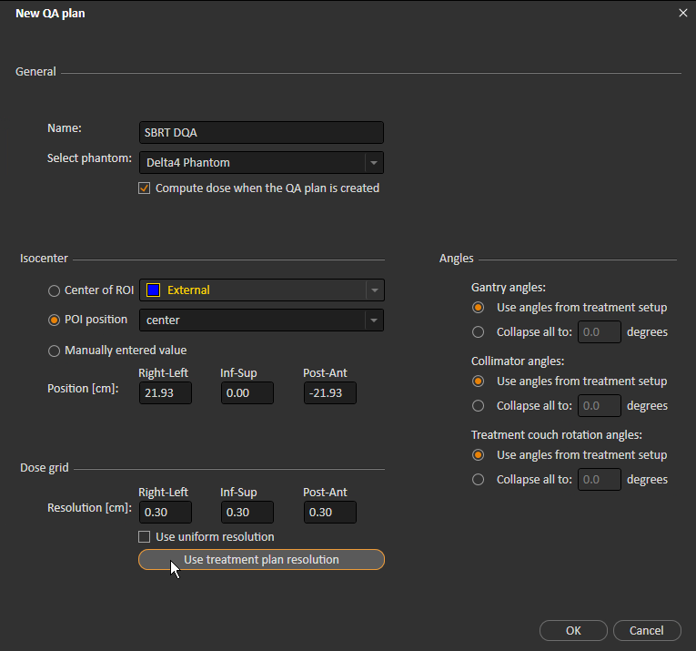

Additionally, the color wash for the case is set.

The script ensures that the phantom electronics will not be irradiated above 2 Gy when the DQA plan is run. The electronics are 20 cm inferior to the center of the phantom, so the script warns the user if the dose at this point >2 Gy.

The DQA plan (RTPLAN and RTDOSE) is exported to a folder called <patient name> <DQA plan name>. If this folder already exists, it is emptied.

### Assumptions

* A patient is open.
* A case is open.
* A plan is open.
* The open plan contains at least one beam set.
* The current beam set is photons.

### Example

The script creates a DQA plan called SBRT DQA, and exports its RTPLAN and RTDOSE to three folders: E1, E2, and ELEKTA.

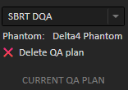

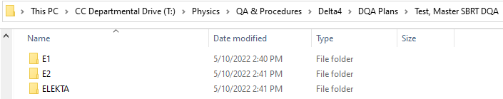

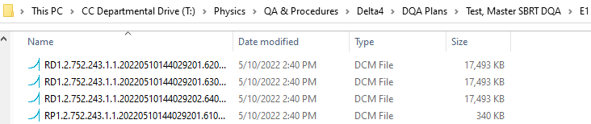

Each RP… (RTPLAN) file has the correct TreatmentMachineName and (4001, 1012) (a RayStation-specific Private Data item) values:

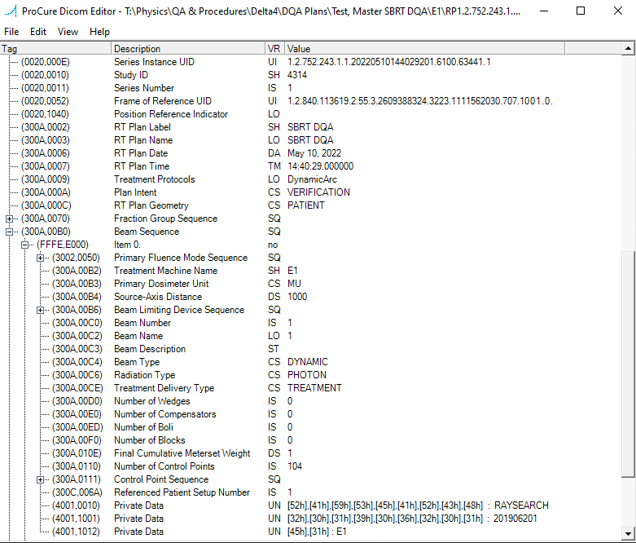

### Coming Soon

* Make DQA plan name unique among all DQA plans for the current beam set instead of the current plan.

## Delete Empty ROIs

Deletes all unapproved ROIs in the current case that are empty on all exams.

Alerts the user of any empty ROIs that could not be deleted because they are part of an approved structure set or a beam set’s dependent approved structure set.

### Assumptions

* A case is open.

### Example

Before running the script, the ROI Empty has no geometries on any exam. The ROI Partially Empty is empty on the current exam but not on all exams:

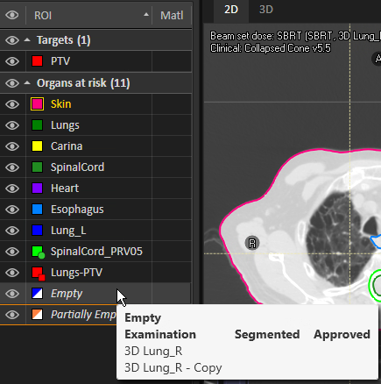 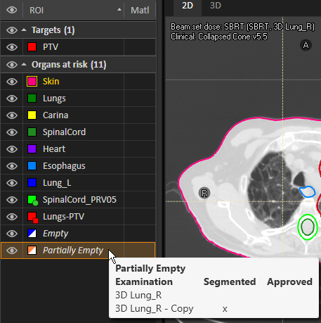

After running the script, the empty ROI has been deleted:

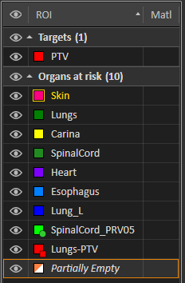

The other ROIs are unaffected.

### Coming Soon

* If a derived ROI depends on an empty ROI, only delete the empty ROI if the derived ROI is also empty.

## Dose Grid Box

Adds a box ROI with geometry that outlines the dose grid of the current beam set.

The dose grid outline in RayStation is (sensibly!) faint. When we want the dose grid to be more visually obvious, we outline it with a box ROI geometry.

The dose grid ROI name is zDoseGrid, made unique in the current case. For example, if there is already an ROI called zDoseGrid, the new ROI is called zDoseGrid (1). The new ROI’s type is Control, and the color is according to the [TG-263 Nomenclature with CRMC Colors](../med-phys-spreadsheets/TG-263%20Nomenclature%20with%20CRMC%20Colors.xlsm) spreadsheet. If there is no ROI zDoseGrid in the spreadsheet, the new ROI is purple, CRMC’s conventional color for Control ROIs.

### Assumptions

* A case is open.
* A beam set is open.

### Example

The dose grid is faint:

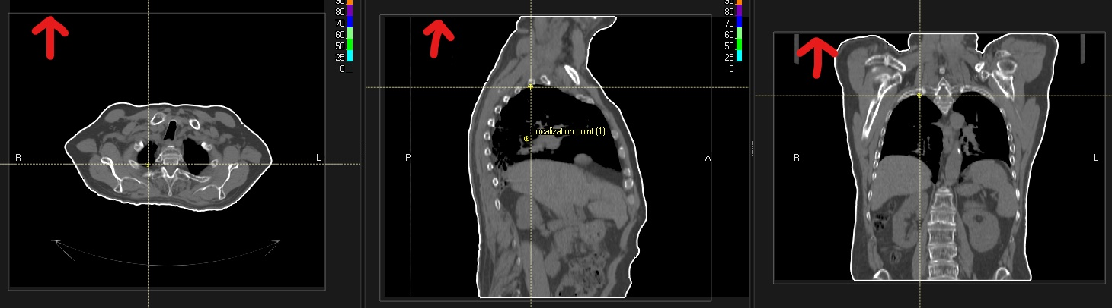

But the purple box is prominent!

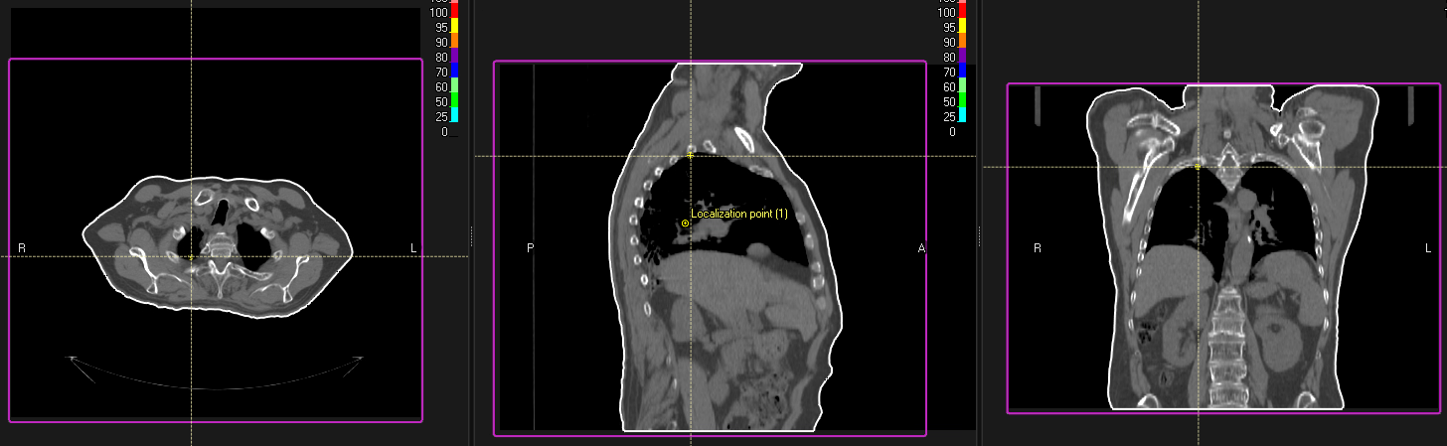

## Exclude from MOSAIQ Export

Includes/excludes the current case's ROIs from export. Makes visible all included ROIs and makes invisible all excluded ROIs.

The following ROIs are always included:

* ROIs with material defined (RayStation does not allow these to be excluded)
* SpinalCord*
* Targets*
* External*

*If a plan is open, empty geometries on the planning exam are excluded. If a plan is not open but an exam is, empty geometries on that exam are excluded.

The following ROIs are always excluded (if they don’t have materials defined):

* Box
* Control

All other ROIs are included if they have contours (see note above) and, if a plan is open, have max dose (D0.035 cc) ≥ 10 Gy.

ROI names with copy numbers are accounted for. For example, SpinalCord (1) is treated as SpinalCord.

### Assumptions

* A patient is open.
* A case is open.

### Example

Consider a case with the following ROIs. The clinical goal is shown to demonstrate the low max dose to ROI Low Dose.

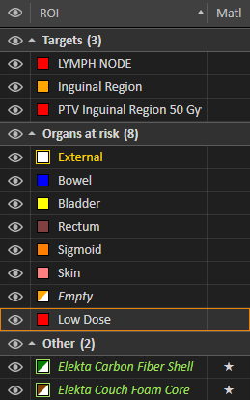



After running the script, the following ROIs have been excluded from export and made invisible:

* Empty: Due to empty geometry on planning exam of current plan
* Low Dose: Due to low max dose (4 cGy < 10 Gy) in the current plan’s dose distribution

Note that even though Elekta Carbon Fiber Shell and Elekta Couch Foam Core are empty, they are not excluded because they have materials defined.

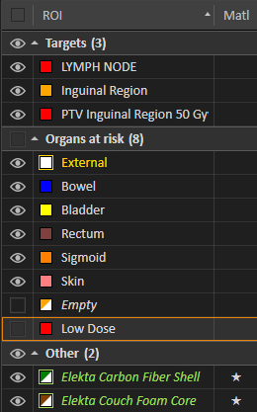

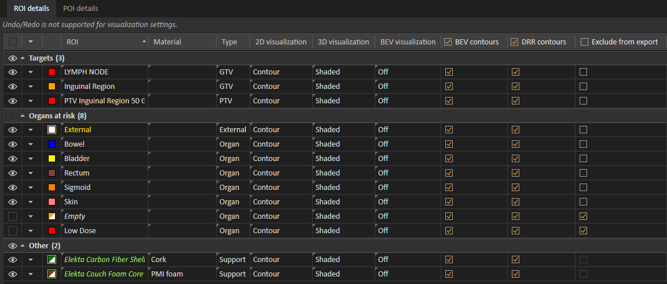

## Export DVH Curves

Enhances RayStation's built-in **Export DVH curves** functionality by allowing the user to modify the following settings:

|  |  |  |
| --- | --- | --- |
|  | Export DVH curves button | Export DVH Curves script |
| Dose unit | cGy | cGy or Gy |
| Volume unit | % | % or cc |
| Bins | 402 bins of irregular width | Regular bin width:   * By dose:   + 10,000 for dose unit cGy   + 100 for dose unit Gy * By volume:   + 100 for volume unit %   + 10,000 for volume unit cc |
| Dose type | Plan dose | Any/multiple of:   * Plan dose * Beam set fraction dose * Beam fraction dose * Evaluation dose   + Dose on additional set   + Deformed dose   + Dose sum   + Perturbed dose |
| ROIs | All | User-selected |
| ROI header info | * RoiName * Roi volume fraction outside grid * Dose unit | * RoiName * Roi volume fraction outside grid * Dose unit   Plus any of:   * Volume unit * Roi volume * Min dose * Max dose * Mean dose |
| File extensions | .dvh | .dvh and/or .txt |

Each exported DVH filename is a description of the dose, plus a timestamp.

### Assumptions

* A patient is open.
* A case is open.

### Example

A previous physicist at our clinic wrote a spreadsheet that computes certain dose statistics from DVH curves exported from the Pinnacle treatment planning system. We want to modify the spreadsheet to work with RayStation DVH curves, but the spreadsheet expects a uniform bin width of 1 percent volume, as well as a max dose in each ROI header. Additionally, to speed up the spreadsheet, we only want curves for the necessary ROIs. Suppose we're analyzing lung plans. Then, we only want the ROIs present in virtually all lung plans—say, Lung_L, Lung_R, Esophagus, Heart, and SpinalCord.

The **Export DVH curves** button produces the following file. The intervals are irregular, and all ROIs are included.

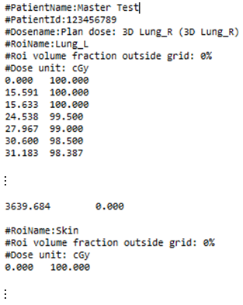

We can customize our settings using the script. Here are the defaults:

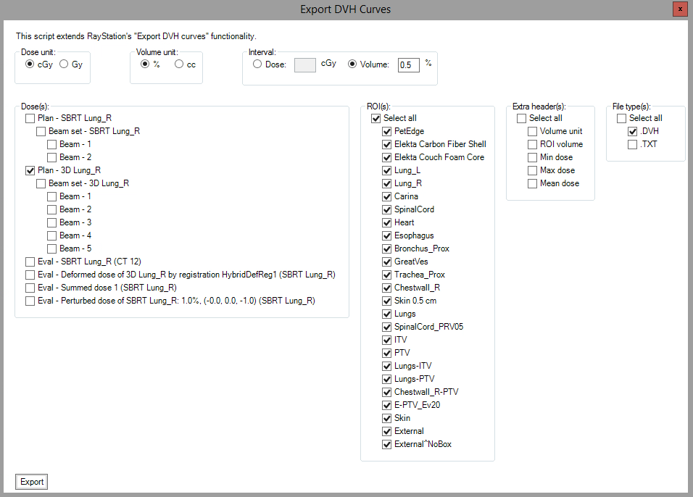

And here are the settings we change:

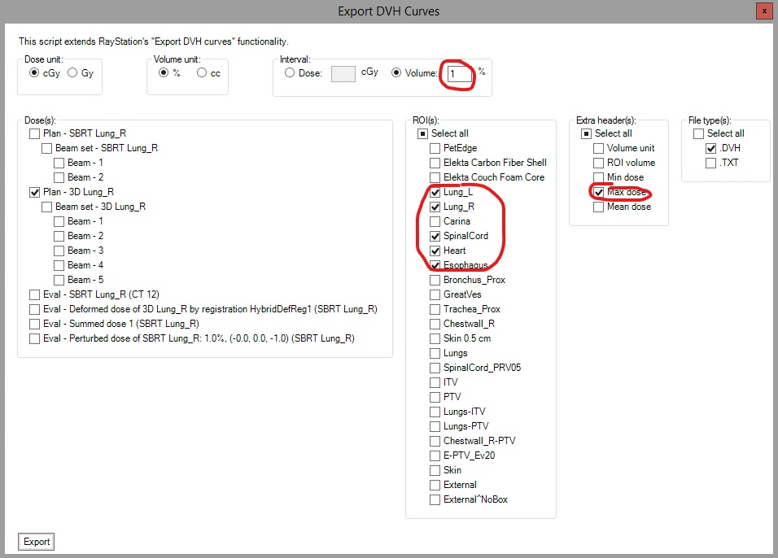

The script creates a file called Plan dose - <plan name> (<planning exam name>) <timestamp>.dvh with a uniform volume interval of 1 percent, and only the selected ROIs:

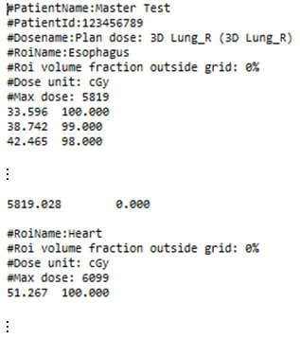

## Export Line Doses

[Coming soon]

## Export to Test Patient

[Coming soon]

## Extend Exam

Extends the current exam so that the target is at least the user-inputted distance from the superior and inferior edges of the exam.

A new, extended exam is created; the original exam is unchanged.

ROI and POI geometries are copied from the old exam to the new. The external geometry is manually added to the new exam instead of copying the external from the old exam. Any derived ROIs whose geometries are updated on the old exam are updated on the new exam.

If the minimum distance is already satisfied, the script alerts the user and does nothing.

The user provides the minimum distance limit in a GUI. This distance must be a number between 0 and 10, inclusive, and must have no more than one digit after the decimal place. The **OK** button in the GUI is disabled until valid input is provided:

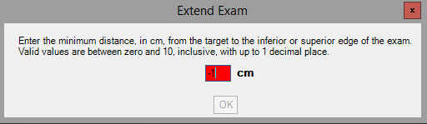 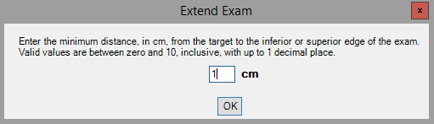

**Number 0–10, so OK button is enabled**

**Negative number, so OK button is disabled**

If a beam set is loaded, its primary prescription is to a target ROI, and that target ROI has a geometry on the current exam, that geometry is used. Otherwise, the first non-empty PTV, GTV, or CTV geometry (checked in that order) on the current exam is used as the target geometry.

The new exam is the same as the old exam name plus the suffix - Extended, possibly with a copy number in parentheses. For example, an extended copy of CT1 is called CT - Extended if there are no exams called CT1 - Extended, or CT1 - Extended (1) if there is already an exam called CT1 - Extended.

### Under the Hood

The script computes the minimum number of slices necessary to reach the minimum distance from the target to the superior or inferior edge of the exam. This computation is based on the desired minimum distance, the current distance, and the slice thickness.

The original exam’s CT DICOM files are exported to a temporary directory, and a new Study Instance DICOM values is computed for the new exam. The appropriate number of copies are made of the DICOM file of the most superior or inferior slice. In each new DICOM file, the Series Instance UID, Slice Location, and inf-sup Patient Position are incremented or decremented appropriately.

Finally, the edited DICOM files are re-imported into the case as a new exam. The new exam is renamed, an external geometry is created on the new exam, ROI and POI geometries are copied from the old exam to the new, and derived ROIs whose geometries are up to date on the old exam are updated on the new exam.

### Assumptions

* A patient is open.
* A case is open.
* The open case contains at least one exam.
* The current exam contains at least one target geometry.

### Example

Consider a plan to a PTV that is very close to the inferior edge of the planning exam:

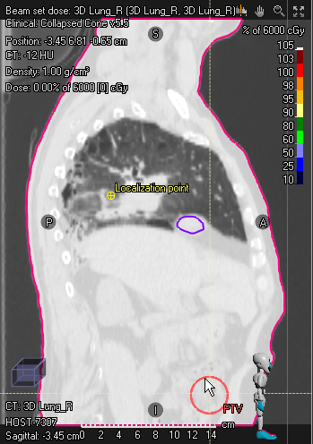

**1.5 cm**

We prefer at least 5 cm between the target and the inferior or superior edge. Running the script:

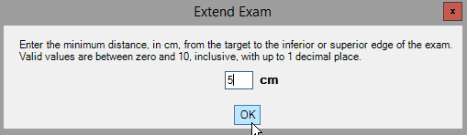

The new exam is inferiorly lengthened and contains the same geometries as the old exam:

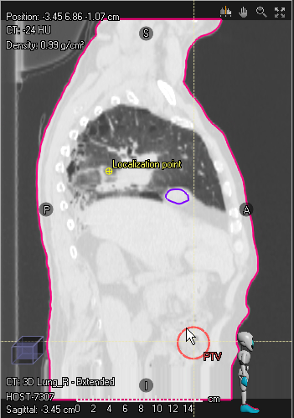

**6 cm**

The distance is not exactly 5 cm due to the slice thickness:

$$\text{number of slices to add}=\left\lceil \frac{\text{desired distance}-\text{current distance}}{\text{slice thickness}}\right\rceil =\left\lceil \frac{5-1.5}{3}\right\rceil ≈\left\lceil 1.167\right\rceil =2$$

Adding 1.167 slices would give us exactly 5 cm between the target and the inferior edge, but adding fractional slices is obviously impossible.

### Coming Soon

* Adjust any dose grids.

## Generate Shifts Comments

Creates and opens a TXT file listing patient shifts (couch shifts, MOSAIQ Site Setup shifts) and CB/AP/PA setup SSD if applicable.

The shifts are the difference between the localization geometry and the beam set isocenter. Shifts are rounded to the nearest tenth. If there is no shift, No shift is printed instead of (0, 0, 0).

The current version of the script in RayStation does not include MOSAIQ Site Setup shifts. A scripter can change this very easily (see Parameters).

The SSD is the SSD of the appropriate setup beam, rounded to the nearest 0.25 cm. If there is a single setup beam with CB or CBCT in the name or description, it is used. Otherwise, if there is a single setup beam with AP (for supine patients) or PA (for prone patients), it is used. Otherwise, the scripts alerts the user and exits.

The output file is named <plan name>-<beam set name> Shifts Comments YYYY-MM-DD HH_MM_SS.txt. For instance, for a beam set SBRT in plan SBRT, a document generated at 10:49:42 on 5/5/22 would be named SBRT-SBRT Shifts Comments 2022-05-05 10_49_42.txt.

### Assumptions

* A beam set is loaded.
* The beam set contains at least one beam.
* The beam set has a localization geometry.
* All beams in the beam set have the same isocenter.
* There is exactly one setup beam containing CB or CBCT in its name or description, or exactly one setup beam containing AP (for supine patients) or PA (for prone patients) in its name or description.

### Example

The beam set SBRT has the following setup. (This is accessed via the **Plan setup…** button in RayStation.)

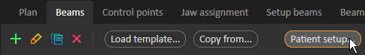

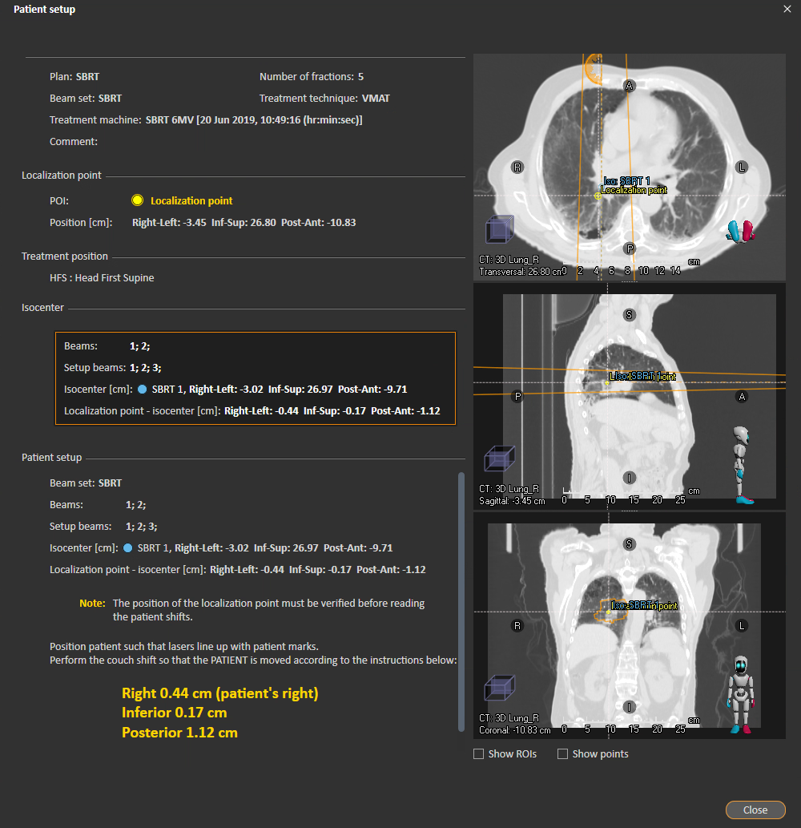

And there is a single CBCT beam, which has an SSD of 84.65:

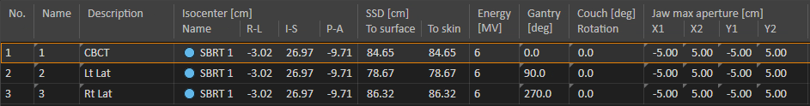

The following output file is created and opened:

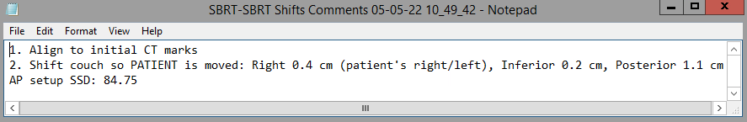

Note that the shifts and SSD do not exactly match due to rounding.

## Last Modified Times

Creates and opens a TXT file listing modification info for several RayStation objects. The file is opened with the default app that opens TXT files on the computer (for us, one of our RayStation servers) on which the script is run.

Writes modification info for the following objects:

* The current patient
* If a case is open, the current case’s:
  + Registrations
  + Structure sets
  + If a plan is open, the current plan’s:
    - Beam sets
    - Plan dose
    - Beam set dose for each beam set that has beams
    - Beam dose for each beam in a beam set that has dose
  + Evaluation doses

Modification info consists of date and user. If the username is in the CRMC Usernames sheet in the [Credentials & Computer Info](../med-phys-spreadsheets/Credentials%20&%20Computer%20Info.xlsx) spreadsheet, the user’s actual name is used instead of their username.

### Assumptions

* A patient is open.

### Example

We have an open plan 3D Lung_R with a single two-beam beam set with dose:

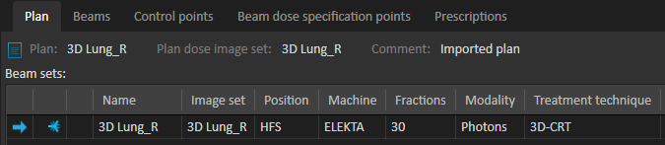

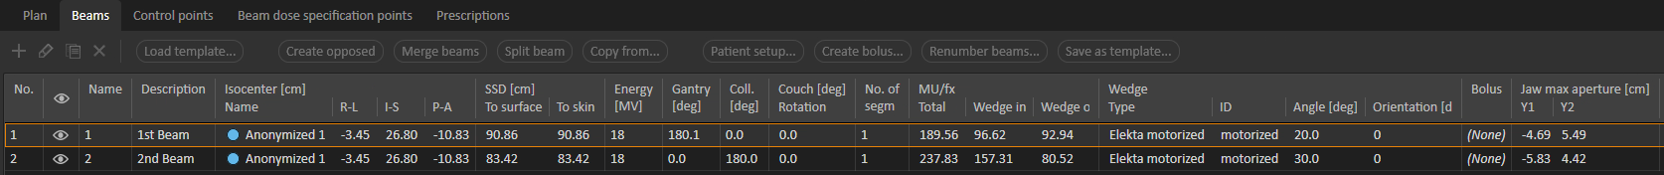

The script generates and opens the following output file:

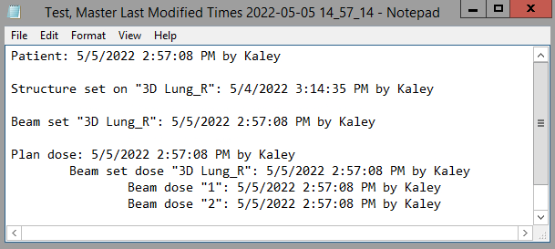

There is no registration or eval dose info listed because there are no registrations in the loaded case.

## List Patients

Writes an Excel file with the MRNs of RayStation patients matching all the user-selected filters from the GUI.

The following filters are available:

* Keyword(s). An MRN matches if any of the provided keys matches any of the following in the patient:
  + Case name, body site, comment, or dx
  + Plan name or comment
  + Exam name
  + Beam set name or comment
  + Beam name or description
  + DSP name
  + Rx description or structure name

A special case for keywords is *pelvi*, which does not match any text also containing *abd*, such as *Abdomen/Pelvis*.

* Patient sex(es)
* Exam patient position(s)
* Beam set treatment technique(s). Techniques are distinct categories; e.g., SBRT beam sets do not match a *VMAT* filter even though SBRT is a type of VMAT.

If both the keyword and patient position filters are applied, and a keyword matches an exam name, the match counts only if the exam has one of the specified patient positions. For example, if a keyword is *SBRT* and the filtered positions are *HFP* and *FFS*, then an HFS exam called *SBRT Lung* will not match.

If both the keyword and treatment techniques are applied, and a keyword matches a beam set name or comment, the match counts only if the beam set’s treatment technique is one of the specified treatment techniques. For example, the keyword *lung* combined with the *SBRT* treatment technique will not match a 3D beam set called *R Lung*.

If no filters are effectively applied, a warning messages appears in the GUI. Obviously, a filter is not applied if it is not checked. But it is *effectively* not applied if no keywords are provided (for the keywords filter) or no or all checkboxes are checked (for a multi-select filter).

In addition to filters, the user also provides the maximum number of MRNs to write to the file. Because the script checks every patient in the database, limiting the number of MRNs can significantly speed up the script. The maximum number of MRNs defaults to [All] for no limit. The input box for the maximum number of MRNs turns red when the input is neither [All] (case-insensitive) nor a positive integer.

The XLSX file contains one MRN per line. If no matching patients were found, it instead contains a single line: *No matching patients.*

Note that patients that someone else already has open are not checked.

### Example

Suppose we need five more HFS female pelvis patients for a structure atlas. We can provide the following settings in the script:

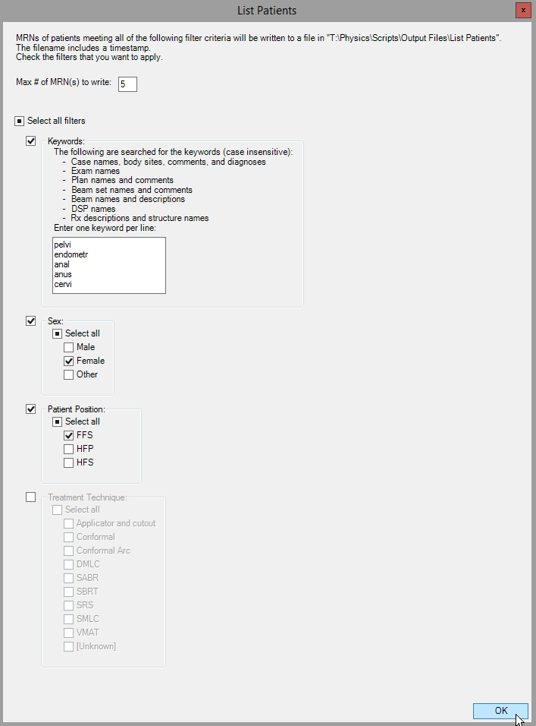

We check the filters to apply: **Keywords**, **Sex**, and **Patient Position**. For the **Keywords** filter, we provide one keyword per line. Keywords don’t have to be whole words, and we take advantage of this with *pelvi* to match either *pelvis* or *pelvic*, *endometr* to match either *endometrium* or *endometrial*, and *cervi* to match either *cervix* or *cervical*. Yet, if we tried *an* to match *anus* or *anal*, we would match anything containing the letters *an*—say, *Head* ***an****d Neck* or ***an****terior*!

(There are more keywords at the top of the input box that you can’t see: *rect*, *blad*, vulv, *uter*, *reproduce*, *genital*, *vagin*, and *ovar*.)

When we click **OK**, the script checks patients in the database until it finds five matching our filters. Then it writes the matching patient’s MRNs to an XLSX file:

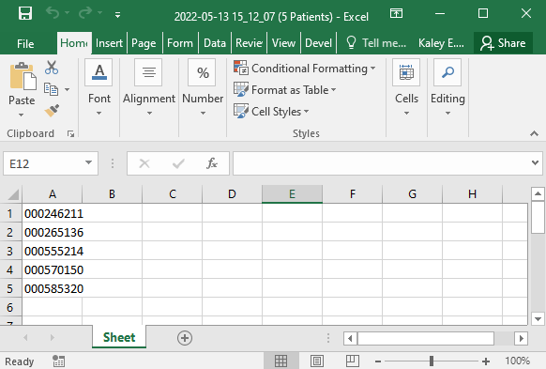

Just to illustrate how matches are determined, let’s see what the script did for the first matching MRN, 000246211.

1. The patient is not locked (open by someone else), so we can check them.
2. The sex filter is applied, and the patient sex matches.
3. The keywords filter is applied, so create a list of texts to search for the keywords:
   1. For all cases containing an exam with the correct patient position: body site, case name, comments, and diagnosis
   2. For all exams with the correct patient position: exam name
   3. For all plans on an exam with the correct patient position: plan name and comments; beam set names, comments, DSP names, beam names and descriptions, and prescription descriptions and structure names (for prescriptions to ROI/POI). Because the treatment technique filter is not applied, the checked beam sets need not have a specific technique.

The complete list of names to check for a keyword is *pelvis*, *bladder 1-28-19*, *bladder*, *converted from sim*, *dsp bladder*, *1*, *ap bladder*, *2*, *pa bladder*, *3*, *r lat bladder*, *4*, *l lat bladder*, *localization point*. This patient obviously matches.

### Coming Soon

* Write the filters to another sheet in the output file. E.g.:

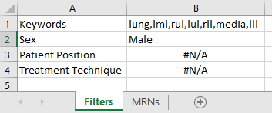

* If a patient is open when the script starts, return to that patient when the script finishes.

## Localize to Beam Iso

Localizes views to the beam isocenter of the current beam set.

If different beams have different iso positions, the user chooses the beam to use, from a GUI.

The script clicks a button in RayStation, so it might need to navigate to where that button is available. But it always returns you to the workspace you started in!

### Assumptions

* A case is open.
* A beam set is loaded.

### Under the Hood

The script creates a spehere ROI geometry centered at the iso, then uses UI scripting to click the **Localize to ROI** button. The issue with UI scripting is that after we perform the desired actions, we should return the user to where they were before running the script. This is accomplished by storing the user’s current location and then using more UI scripting to go back to that location after clicking the **Localize to ROI** button.

The **Localize ROI** button is in **Patient modeling** (module) > **Structure definition** (submodule) > **ROI tools** (tab). The user’s current location is determined by which submodules/tabs are currently visible. For example, if the **Plan setup** submodule button is visible, then the user is in the **Plan design** module. We only check the current submodule (e.g., Image Registration) if the user is in Patient modeling, and the current tab (e.g., **POI tools**) if in **Structure definition**. This is because when you return to a module/submodule after using another one, you are returned to the last submodule/tab that you were in. Only in **Patient modeling** and **Structure Definition** does the script change submodule and tab.

### Example

Let’s localize to the beam iso for the B1 beam set.

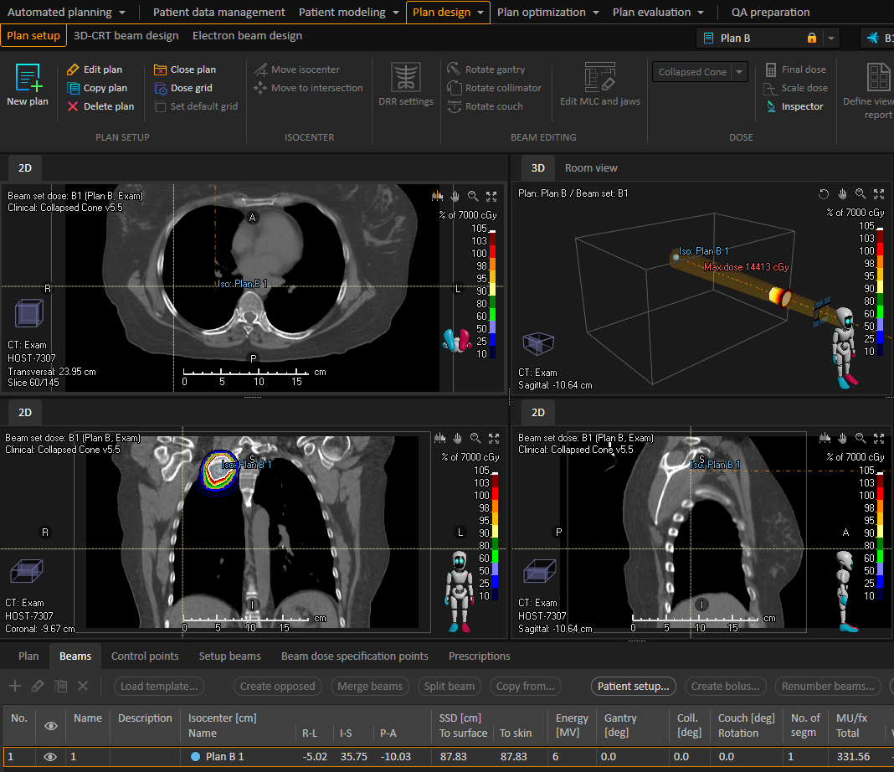

**Current user location**

**Iso coordinates**

The script navigates to Patient modeling > Structure definition > ROI tools to click the Localize ROI button, then returns you to Plan design > Plan setup.

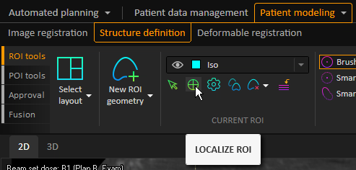

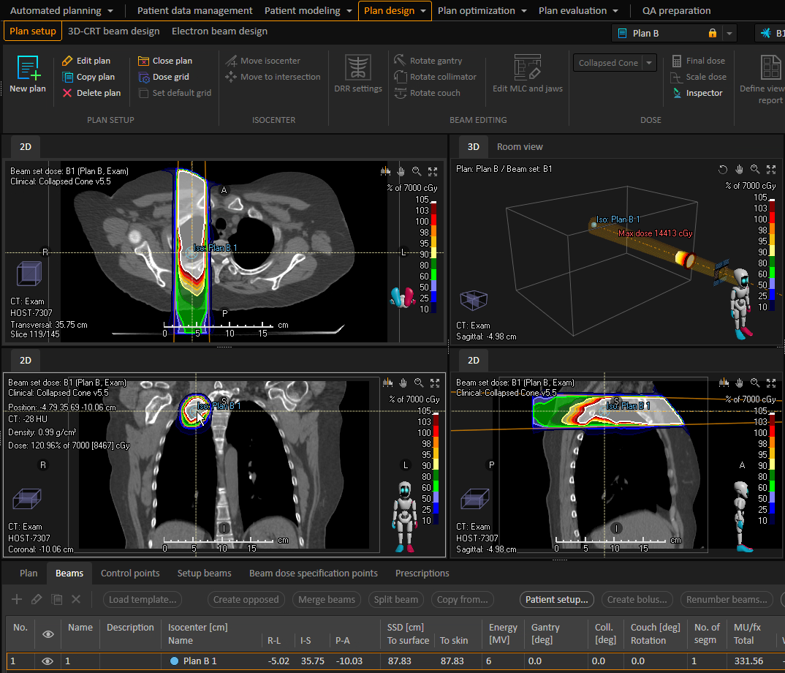

**Iso coordinates**

## Parse Logfiles

Writes information from RayStation logfiles to a table in an Excel spreadsheet.

RayStation’s logfiles are a useful troubleshooting tool; RaySearch support often references them when responding to tickets. These logfiles, at least for CRMC’s RayStation installation, are located at C:\ProgramData\RaySearch. There are two types of logfiles:

* Exceptions. These files contain information on a single exception that was thrown. Their file extension is .exn.log.
* General. These files contain information on all logged events, including exceptions. Their file extension is .log. Because these logfiles include exceptions, the script ignores .exn.log files.

The generated spreadsheet is named Parsed Logfiles YYYY-MM-DD HH_MM_SS.xlsx (e.g., Parsed Logfiles 2022-04-22 02_05_05.xlsx).

Each row in the table represents a log event. The table contains the following fields:

|  |  |  |  |
| --- | --- | --- | --- |
| **Field Name** | **Description** | **Source** | **Example Value** |
| Date | The datetime of the log event, in the format M/D/YYYY H:MM AM/PM. | The timestamp field of the event. | 4/22/2022 3:12 PM |
| App | The RayStation app that generated the event. | The first part of the logfile name. | RayStationDoctor |
| App Version | The RayStation version that generated the event.  Is not present in RayStation_Storage_Tool events. | The ApplicationVersion field of the event. | 8.1.1.8 |
| User | The username of the user who generated the event  Is not present in RayStation_Storage_Tool events. | The User field of the event. | CRMCHEALTH\jm84u |
| Machine | The computer that generated the event. | The Machine header field in the logfile. | D117RAYAPP1 |
| Severity | The severity level of the event. | The severity field of the event. | Information |
| Type | The type of event. | The context field of the event. | General |
| Exception | The exception that the event was logged for.  Does not apply to all events. | Part of the message field of the event. | RaySearch.CoreUtilities.LogicalException |
| Exception Name | The user-friendly name of the exception. Only present for exceptions that involve a BROKEN RULE. | The Name field of an exception’s BROKEN RULE. | Validate isocenter name |
| Message/Description | The message associated with the event.  For RayStation Scripting Log events, this is always Using scripting environment ‘___’. Because Scripting Env is another field, Message/Description is not listed for RayStation Scripting Log events. | Part or all of the message field of the event. For exceptions, also includes the Description field of the event’s BROKEN RULE, if present. | No licenses available; Error during license checkout of feature: 11_0_1-CLI-rayArc-4b79ac7aadf54e1e87f9ac345ecda85e |
| Server | The SQL server on which the event occurred. Only applies to events that raised a SqlException. | The Server field of the event. | D117RAYSQL\raystation |
| Scripting Env | The scripting environment in which the event occurred. Only applies to RayStation Scripting Log events. | The scripting environment name in the event’s message field. | CPython 3.6 (64-bit) |
| Script | The Python script that generated the event. Only applies to RayStation Scripting Log events. | The script name in the event line Running ‘___’ from database. | CopyPlanandBeamSet11A |
| Pt | The current patient when the event was generated. Only applies to RayStation Scripting Log events. | The patient name in the event line Current patient is patient with name: ___ | Test^Master |
| Filename | The absolute filepath of the logfile. |  | C:\ProgramData\RaySearch\RayStationPlanning_Errors_20220117210633.log |
| Full Text | The full text of the event (from which most other fields were extracted). |  | "2022-03-24 18:28:10.969Z 236 Information RayStation Scripting Log Using scripting environment 'CPython 3.6 (64-bit)'  ⋮  Patient UUID: 6c3943df-26b6-44ee-ba55-b3e38dfb0c70" |

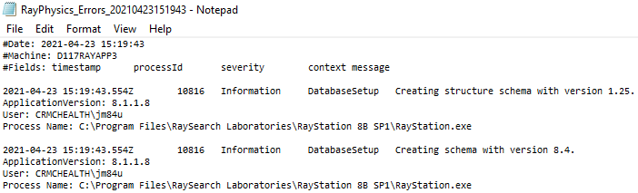

**App**

**Machine**

**Date**

**Severity**

**Type**

**Message/Description**

**App Version**

**User**

**Event**

**Event**

**App**

**Date**

**Machine**

**Severity**

**Type**

**Scripting Env**

**Script**

**Pt**

**App Version**

**User**

**Event**

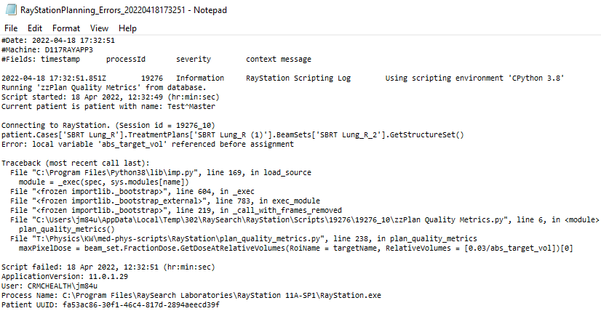

### Example

Suppose user vwxyz says that the RayStation Planning scripts keep erroring out on her today. I can run Parse Logfiles and sort the resulting table by newest to oldest Dateand then filter by App (RayStationPlanning_Scripting) and User (abcde).

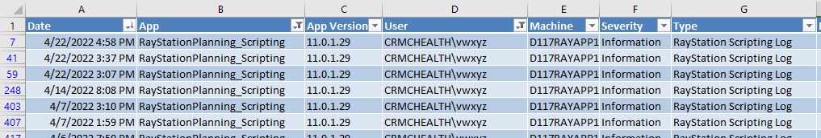 ⋮

…

## Plan Check

Performs an [initial physics review plan check](../med-phys-notes/Procedures/RayStation/Initial%20Physics%20Review%20Plan%20Check.docx) on photon beam sets in the current plan.

Writes and opens a PDF report named <patient name> <YYYY-MM-DD HH_MM_SS>.pdf to the specified output directory. The report is divided into several sections:

* Errors (red): Things that really should be fixed
* Warnings (yellow): Things that should be fixed but aren't just dire
* Passing (green): Things that don't need to be fixed. This section is divided into subsections for Patient, Case, Plan, and each Beam Set.
* Manual Checks (blue): Things the script can't check, so the user should check manually. These mainly relate to MOSAIQ.

The following checks are performed. Red text means that a failure is considered an error; yellow, a warning. Obviously, some checks depend on other checks’ passing. For instance, we can’t check the name of the external if an external does not exist. If a check’s dependencies do not all pass, then the check is not included in the report. Additionally, not all checks apply to all plans. Some are explicitly stated to apply only to certain types of plans, such as SBRT. Others are implicitly included—e.g., we can’t check for adjacent boli if there aren’t multiple boli.

The following assumptions are made but not checked:

* The current beam set is the “main” beam set that will be exported to MOSAIQ.
* Each plan optimization optimizes a single beam set.
* The “initial sim” plan name is *Initial Sim* or *Trial_1* (case insensitive).
* The “initial sim” plan, if it exists, has just one beam set, and all beams in that beam set share the same isocenter position.

**Patient**

* Patient ID format

ID is a valid CRMC MRN: three zeroes followed by any six digits.

* + Example passes:
    - 000123456
  + Example failures:
    - 123456789
    - SolidWater
* Patient name

Name (from the DICOM PatientName attribute) is formatted correctly: no leading or trailing carts (*^*), name is not in all caps, and each name part is capitalized.

* + Example passes:
    - Jones^Bill^M
    - McWilliams^Bill
  + Example failures:
    - Nofirst
    - JONES^BILL
    - Jones^Bill^
* Patient DOB

DOB is reasonable: not in the future and not over 125 years ago.

* + Example passes:
    - 1/1/1950
  + Example failures:
    - 1/1/1850
    - 1/1/2050

**Case**

* External exists

An ROI of type *External* exists.

* External name

The ROI of type *External* is named *External*.

* External type

The ROI named *External* is of type *External*.

* Case information exists

Case information is filled in: Body Site, Diagnosis, and Physician Name.

* *MD* suffix

Physician name includes *MD* suffix. This is necessary for insurance purposes.

* Imaging system

All exams have imaging system *HOST-7307*.

* Exam name

All exam names include a date.

* + Example passes:
    - Exam A 7.8.2020
    - L Lung 20 May 2021
  + Example failures:
    - Exam A
    - L Lung may-20-21
* Couch ROIs exist

All couch ROIs from the applicable couch structure template exist. The template is Elekta Couch if the current beam set is supine, Elekta Prone Couch if prone. Not applicable for VMAT head and neck plans. A failure is an error only if there are IMRT beam set(s), a warning otherwise.

* “Initial Sim” plan exists

A plan named *Initial Sim* or *Trial_1* (case insensitive) exists. For plans with no SBRT beam sets, this “initial sim” plan must be on the planning exam.

**Plan**

* Planner exists

The planner is specified.

* External geometry

The external is contoured on the planning exam.

* Prostate ROIs

For prostate plans, Bladder, Rectum, Colon_Sigmoid, and Bag_Bowel ROIs exist. A prostate plan is identified by *pros*, *PB*, *bed*, or *fossa* (case insensitive) in the case Body Site, Case Name, Comments, Diagnosis; plan Comments or Name; or any beam set name.

* Empty geometries

There are no empty geometries on the planning exam.

* Missing dose statistics

Dose statistics do not need updating. If they do, this button  is shown in the **Plan Optimization** and **Plan Evaluation** modules in RayStation.

* Dose grid bounds

Dose grid does not extend outside planning exam, and there is at least a 1 px “padding” between each dose grid edge and the corresponding exam edge. Only applies if there are no couch geometries.

* Stray contours

No geometries extend outside the external geometry on the planning exam. Only applies if voxel size is uniform. Allow a margin of error equal to the voxel size. Ignore Bolus, Control, External (obviously), Field-of-view, Fixation, and Support (e.g., couch) geometries, and geometries that have a material defined. Only consider parts of the geometry and external geometry that are inside the dose grid or planning exam bounds, whichever is stricter, in each direction.

* External-couch boundary

For plans with SBRT beam set(s), the external and couch geometries exactly meet.

* Gap between boli

There are no gaps between adjacent boli. Boli with derived geometries are ignored. To find a bolus adjacent to a given bolus, find the smallest distance between a point in the given bolus and a point on any other bolus such that both coordinates lie on the external geometry and the two boli do not overlap. There is a gap between adjacent boli if the closest points do not belong to both boli.

* Geometry bounds

All planning exam geometries are contained within the dose grid. Ignore Field-of-view geometries, and Bolus, Fixation, or Support geometries that have a material defined.

* Uniform voxel size

Dose grid voxel *x*, *y*, and *z* sizes are equal.

* Small voxel size

Dose grid *x*, *y*, and *z* voxel sizes are at most 2 mm for SBRT and SRS plans, at most 3 mm otherwise.

* Clinical goals exist

The plan contains clinical goals.

* Dose exists

The plan has dose.

* Clinical goals pass

All evaluable clinical goals pass. A goal is non evaluable if its ROI is empty or has been updated since last voxel volume computation.

* Loc point

The planning exam has a localization geometry.

* Gantry collision

The gantry is unlikely to collide with the couch or patient. Collision is *likely* if the minimum distance between the gantry (at any position) and the couch/patient is below 41.5 cm but above 40 cm, and *very likely* if this distance is below 40 cm.

**Each Beam Set**

* Beam names are beam numbers

Beam names, including setup beams, are the same as their numbers.

* Unique beam names

Beam names, including setup beams, are unique across all non-“initial sim” plans in the patient.

* Unique beam numbers

Beam numbers, including setup beams, are unique across all non-“initial sim” plans in the patient.

* Setup beams exist

Either a CBCT, or an AP/PA and a lat setup beam exist. A CBCT setup beam has CB in its name, an AP/PA setup beam has a gantry angle of 0° or 180°, and a lat setup beam has gantry angle of 90° or 270°.

* Machine name

Machine name is *SBRT 6MV* for SBRT or SRS beam sets, *ELEKTA* otherwise.

* Small *z*-coordinate

The *z*-coordinate of each beam isocenter is 100 or less.

* Rx

The beam set has a prescription defined.

* Dose exists

The beam set has dose.

* DSPs near target

For primary Rx to PTV, all beam set DSPs are within the PTV. For primary Rx to point, all beam set DSPs are within the 80 percent isodose line.

* Iso from initial sim

For beam sets with a localization geometry, all beam isocenters have the same coordinates as the isocenter from the “initial sim” plan. For beam sets without a localization geometry, all beam isocenter coordinates are the same as in “initial sim.”

* Dose algorithm

The dose calculation algorithm is CCDose.

* Autoscale to Rx

**Autoscale to prescription** is enabled.

* Beam energy

For VMAT plans, including SBRT and SRS, all beam energies are 6 MV.

* Optimization tolerance

For VMAT plans, including SBRT and SRS, the optimization tolerance is 10-5 or less.

* Compute intermediate dose

For VMAT plans, including SBRT and SRS, lung beam sets, **Compute intermediate dose** is enabled. A lung beam set is identified by lung in the beam set name, plan Name, or case Case Name or Body Site.

* Gantry spacing

For VMAT plans, including SBRT and SRS, all beams have gantry spacing of 3 cm or less.

* Max delivery time

For SRS and SBRT beam sets, all beams have maximum delivery time set to 180 seconds; other VMAT, 120 seconds.

* Delivery time

For VMAT plans, including SBRT and SRS, all actual beam delivery times are less than 110 percent of the maximum delivery time.

* Constraint on max leaf distance per degree

For VMAT plans, including SBRT and SRS, the constraint on max leaf distance per degree is enabled.

* Max leaf distance per degree

For VMAT plans, including SBRT and SRS, the max leaf distance per degree is set to 0.5 or less.

* Max dose

For SBRT and SRS beam sets, the max dose to the external is less than 140 or 125. For other VMAT, less than 110 or 108. Otherwise, less than 118 or 110.

* Modulation

For VMAT plans, including SBRT and SRS, MU for each beam is no more than 110 percent of that beam’s point dose.

**Manual**

* Admission date

Patient admission date is filled in in MOSAIQ.

* Rx name

The Rx name in MOSAIQ matches the plan name in RayStation.

* Dose sums

Any dose sums that the MD requested are present in RayStation.

* Structures to export

Structures are included/excluded in export to MOSAIQ according to the rules in the Exclude from MOSAIQ Export script.

* MLC movie

For VMAT plans, including SBRT and SRS, the MLC movie reveals no weird/unexpected MLC positions.

* Rx to % volume

If the current beam set’s primary Rx is to a percent volume of the target, that is not 100 percent, this is specified in MOSAIQ.

### Assumptions

* A patient is open.
* A case is open.
* A plan is open.
* The current plan has at least one beam set.
* The current plan has at least one photon beam set.
* The current beam set is either supine or prone.

### Under the Hood

The script uses the reportlab Python package to create the report. Each heading or check result is a ReportLab element, and all elements are combined to build the PDF.

### Example

Running Plan Check on a recently treated SBRT lung plan creates and opens a report called Last, First MI 2022-05-24 16_31_07.pdf.

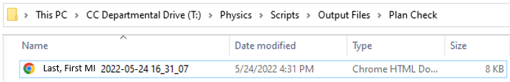

It’s automatically opened in Adobe Reader on the RayStation server.

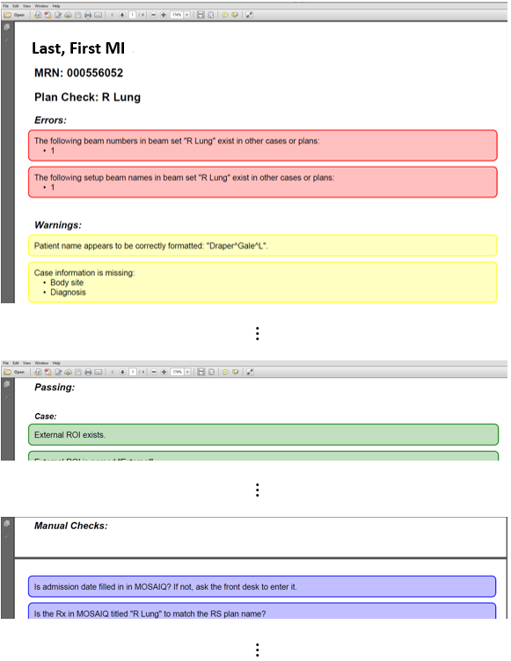

### Coming Soon

* Collision check for all plans, not just SBRT (test on patient 000359161, where the gantry collided with opposite breast).
* Not only all beams in beam set have same iso, but all setup beams as well.

## Plan Quality Metrics

Generates and opens a PDF report of selected plan quality metrics for the current plan.

The following metrics are computed for each beam set in the current plan. Doses are total, not fractional.

Note that I wrote this script before realizing that a beam set cannot lack fractionation. Oh, well, maybe in a future version of RayStation, this check will be necessary. :)

* Paddick conformity index (CI)
  + (Volume of intersection of target and 100% Rx isodose)2 / [(Volume of 2.2 cm target expansion and 100% Rx isodose) × (Volume of target)]
  + Omitted if the beam set lacks fractionation or Rx or if there are no target geometries on the beam set planning exam
* RTOG (traditional) CI
  + (Volume of intersection of 2.2 cm target expansion and 100% Rx isodose) / (Volume of target)
  + Omitted if the beam set lacks fractionation or Rx or if there are no target geometries on the beam set planning exam
* CTV homogeneity index (CI)
  + (Target D5% - D95%) / Rx
  + Omitted if the beam set lacks fractionation or Rx or if there are no target geometries on the beam set planning exam
* Gradient index (GI):=
  + (Volume of 50% Rx isodose) / (Volume of 100% Rx isodose)
  + Omitted if the beam set lacks fractionation or Rx or if there are no target geometries on the beam set planning exam
* D0.035 cc
  + Maximum dose, in cGy, at any 0.035 cc of the target
  + Omitted if beam sets lacks fractionation or if there are no target geometries on the beam set planning exam
* % coverage
  + % of target volume receiving at least the Rx dose
  + Omitted if beam set lacks fractionation or Rx or if there are no target geometries on the beam set planning exam
* V12 Gy
  + Total volume receiving at least 12 Gy dose
  + Omitted if beam set lacks fractionation
* V4.5 Gy
  + Total volume receiving at least 4.5 Gy dose
  + Omitted if beam sets lacks fractionation
* Dmean for Brain
  + Average dose to Brain structure
  + Omitted if Brain geometry is empty on beam set planning exam

### Assumptions

* A patient is open.
* A case is open.
* A plan is open.

### Example

Given plan Plan A with beam sets A1 and A2 on exam Exam, which has three target geometries but no Brain geometry:

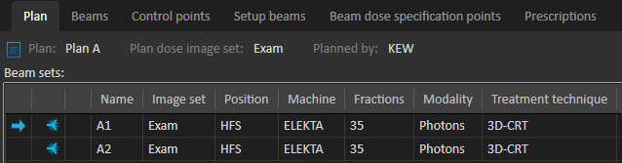

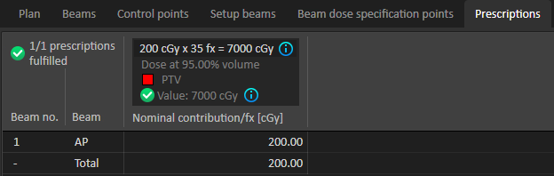 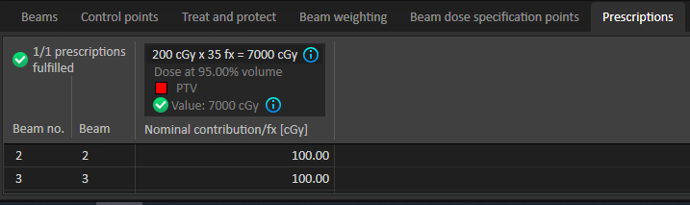

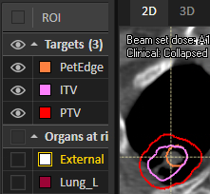

The script produces a PDF report called <last>, <first> <plan> YYYY-MM-DD HH_MM_SS.pdf:

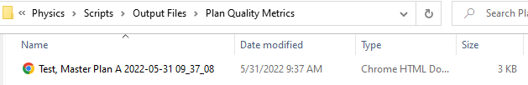

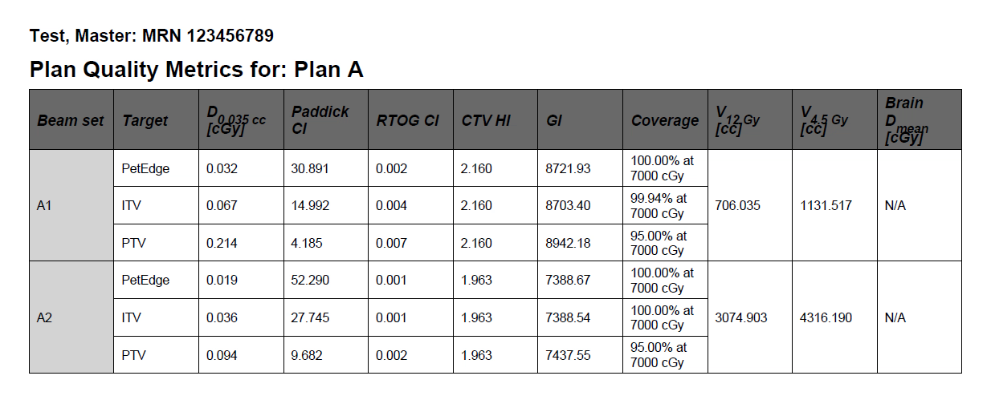

And here are various table possibilities for a single-beam set plan:

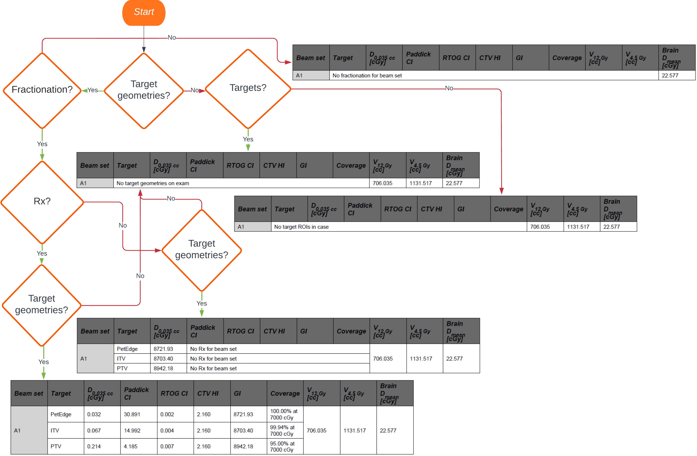

### Coming Soon

* Account for beam sets without dose.

## Prepare Exams

Prepares the latest exams in the case, for use in treatment planning.

Sets imaging system, creates 4DCT group (if necessary), and creates AVG and/or MIP (if necessary).

Ignores exams that have an approved plan or whose names indicate that they only exist to be included in a structure template

Renames exams:

* For SBRT exams:
  + Gated exams (exam description includes *Gated*): Gated __% YYYY-MM-DD, Gated 0% (Max Inhale) YYYY-MM-DD, or Gated 50% (Max Exhale) YYYY-MM-DD
  + Average (exam description includes *AVG*): AVG (Tx Planning) YYYY-MM-DD
  + MIP (exam description includes *MIP*): MIP YYYY-MM-DD
  + Non-gated (exam description includes *Non-Gated*): 3D YYYY-MM-DD
* For other exams, if name does not include a plan or case name:
  + If there are plans on the exam, prepend name with name of first plan on the exam
  + If there are no plans on the exam, prepend name with case name

Any exam name may include a copy number to prevent duplicate exam names.

The 4DCT group is created from any of the gated exams that are not already part of a 4DCT group.

If a non-gated exam exists and an average exists or was created, deforms from the non-gated to the average and deform POI geometries. Because an external geometry is required on the reference exam, an external geometry is created on the non-gated exam if it doesn’t already exist.

### Assumptions

* A case is open.

### Warnings

* The non-gated exam could not be deformed to the average because the case lacks an external ROI.

### Example

We have an SBRT lung case with 10 gated exams, a non-gated exam, and average exam, and a MIP exam sent over from sim. The non-gated exam has a single POI geometry, LocPoint.

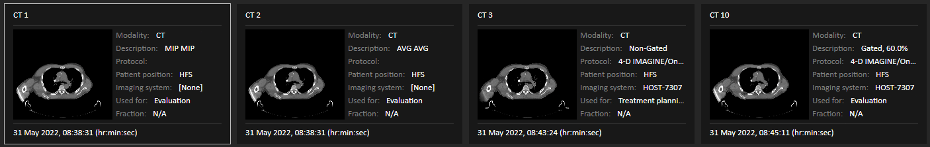…

All of the exams in the case have the same date, so they are selected for preparing. The script creates a 4DCT group, called 4D Phases 2022-05-31, of all gated exams that are not already part of a gated group (that’s all of the gated exams). The average, MIP, and non-gated exams are renamed AVG (Tx Planning) 2022-05-31, MIP 2022-05-31, and 3D 2022-05-31, respectively. The imaging system is set to HOST-7307.

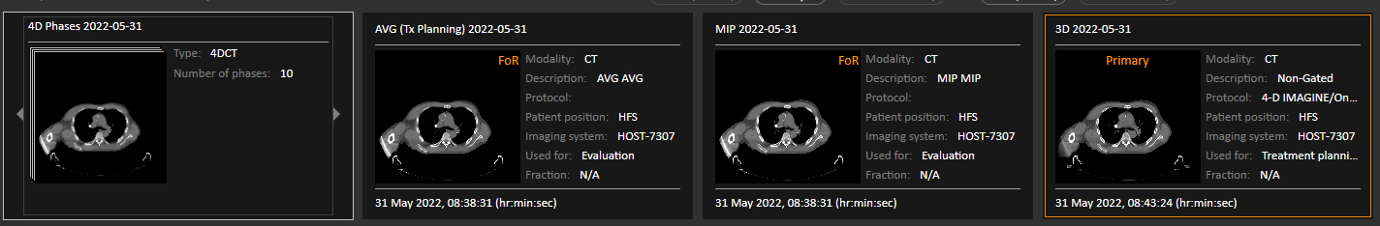

The non-gated exam is deformably registered to the average.

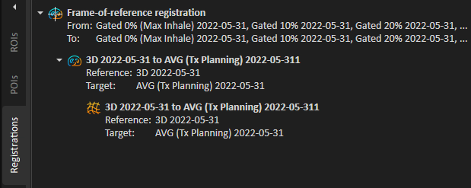

The LocPoint geometry is deformed to the average.

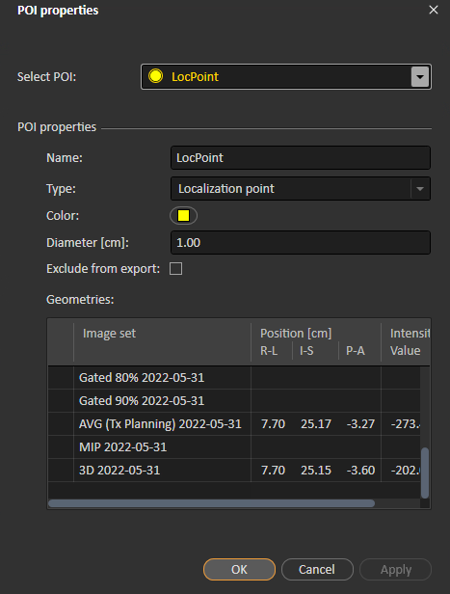

## Print Report

[Coming soon]

## QACT Adaptive Analysis

Performs an analysis on a TPCT and a QACT to determine whether an adaptive plan is needed.

The TPCT is the current plans. Possible QACTs:

* Are not the TPCT (obviously)
* Are not registered with the TPCT in the opposite direction (QACT to TPCT)
* Are not in the same frame of reference as the TPCT
* Have nonempty or unapproved external geometries (if geometry is empty and unapproved, a geometry can be created)

Using a GUI, the user chooses which TPCT geometries to copy and which to deform to the QACT. If there are multiple possible QACTs, the user also chooses the QACT. Support and fixation geometries may not be deformed, only copied. Selected geometries that are approved on the QACT are ignored.

The script rigidly registers the TPCT to the QACT if they are not already registered, then pauses to allow the user to manually adjust the registration if desired. Then, a deformable registration is created (with a focus on bone) if it doesn’t already exist. All POI geometries on the TPCT are deformed to the QACT. The user-selected ROI geometries are copied or deformed from the TPCT to the QACT.

For each beam set that has dose in the current plan, the script computes dose on the QACT and updates dose grid structures for the new evaluation dose.

Finally, the script adds a date and (TPCT)/ (QACT) to the TPCT/QACT exam names, if necessary.

### Assumptions

* A case is open.
* A plan is open.
* There is more than one exam in the open case.
* The current case contains an External ROI.
* The TPCT contains an External geometry.
* There is at least one possible QACT (see above criteria).

### Warnings

* Certain beam sets in the plan on the TPCT have no dose, so they weren’t computed on the QACT.

### Example

A patient had their first sim on April 4, 2020. On May 5, he was resim’d to determine whether his significant tumor shrinkage warranted an adaptive plan. The patient’s case has two exams: H&N 4/9/20 and H&N 5/5/20. The latter exam was just now imported from sim: it has no geometries, and the old exam is not registered to it.

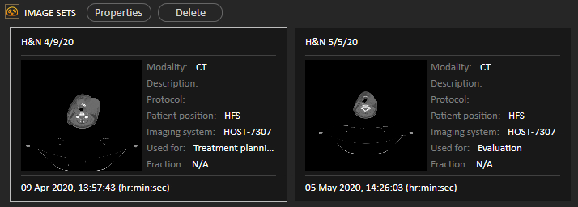

The script launches this GUI:

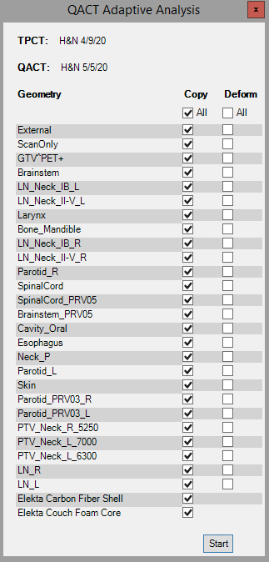

The TPCT is the current plan’s planning exam (H&N 4/9/20), and there is only one possible QACT: H&N 5/5/20. By default, all geometries will be copied. Note that the two Support geometries, Elekta Carbon Fiber Shell and Elekta Couch Foam Core, may not be deformed. Also, a geometry may not be both copied and deformed, so when a checkbox is either column is checked, the other checkbox in that row is checked or unchecked accordingly.

We will deform the external, all four targets, and the brainstem and spinal cord, and copy the couch structures and ScanOnly.

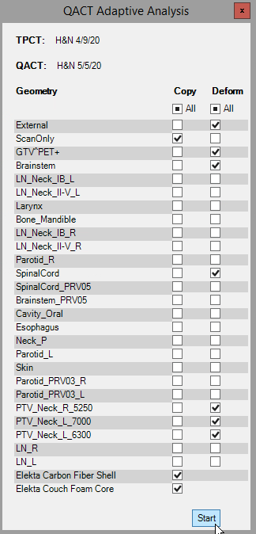

Because the TPCT is not yet registered to the QACT, the script does this, and we are moved to the Image registration tab and prompted to manually edit the registration.

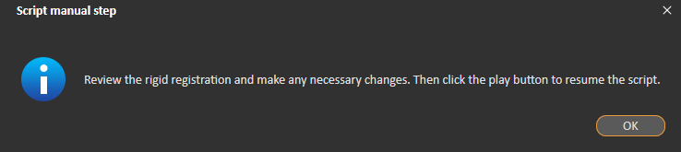

When the script finishes, the exam names have been changed.

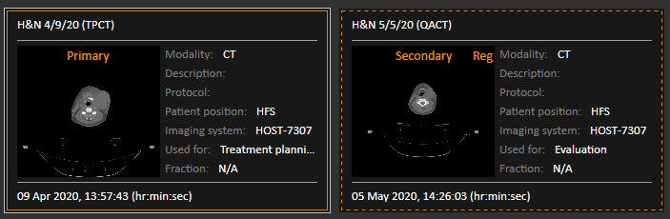

There are new registrations: the rigid and the deformable.

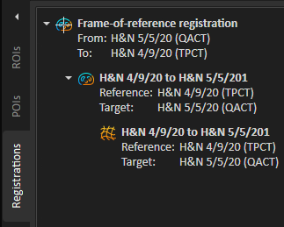

**Deformable**

**Rigid**

In the **Fusion** view, notice the deformed targets and OARs:

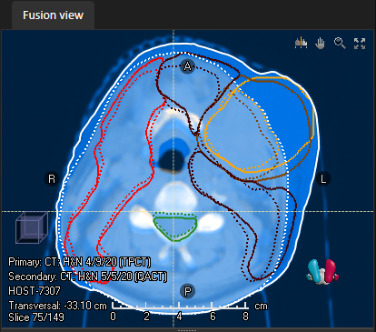

**QACT (dashed line)**

**TPCT (solid line)**

And the copied couch and ScanOnly geometry:

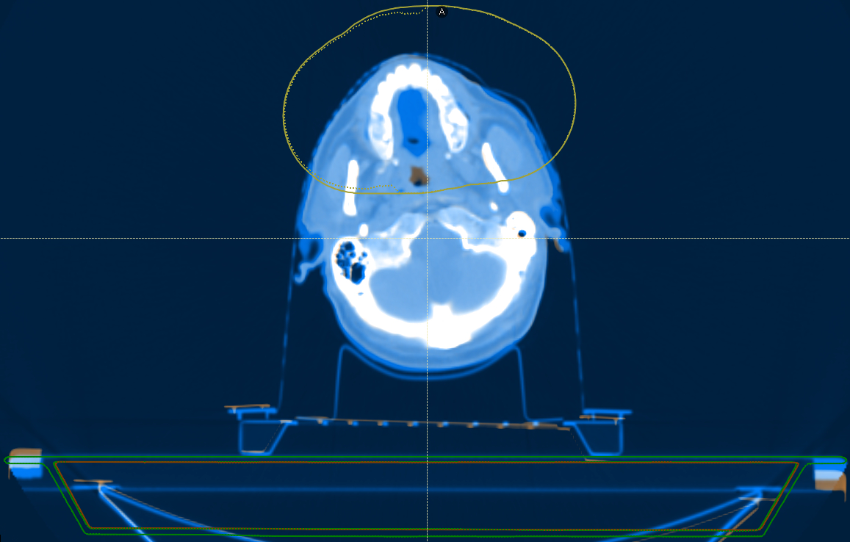

The POI geometries are also deformed.

Based on the differences between the exams and between the geometries on each exam, you can decide whether the patient needs an adaptive plan.

## SBRT Lung Analysis

Generates and opens a PDF report of selected [RTOG 0813](../../Physics%20Papers,%20etc/RTOG/RTOG%200813%20(SBRT%20Lung).pdf) statistics for SBRT lung plan(s) and/or dose(s) on additional set. Other types of evaluation doses are not supported.

The user chooses the following from a GUI:

* The PTV. Defaults to the target of the current beam set’s primary prescription if it has contours on any exams that also have the other required geometries (see below); otherwise, a random PTV that does fit this criterion. When a PTV is selected, plan and eval dose checkboxes are enabled or disabled based on the PTV geometries on their exams. The checkbox is disabled if the PTV geometry is empty or if interpolated stats are selected and the PTV volume is outside the range in the RTOG 0813 table. A disabled plan or eval dose checkbox has a highlighted message beside it describing why it is disabled.
* The statistic(s) to compute. Defaults to all of the following:
  + Traditional CI (R100%)
    - (Volume of isodose ROI for 100% of Rx) / (Volume of PTV)
    - ___[1]___[1.2]___[1.5]___
  + Paddick CI
    - (Volume of intersection of PTV, and isodose line for 100% of Rx) / [(Volume of PTV) * (volume of isodose ROI for 100% of Rx)]
    - ___[1]___[1.2]___[1.5]___
  + GI (R50%)
    - (Volume of isodose ROI for 50% of Rx) / (Volume of PTV)
    - __[Interpolated cutoff for minor deviation]__[Interpolated cutoff for major deviation]___
  + D2cm [%]
    - Maximum dose, as a % of Rx, to any 0.035 cc of E-PTV_Ev20 (normal tissue)
    - __[Interpolated cutoff for minor deviation]__[Interpolated cutoff for major deviation]___
  + Max dose @ appreciable volume [%]
    - Maximum dose, as a % of Rx, to any 0.035 cc of the external
    - ___[123]___[130]___[135]___
  + V20Gy [%]
    - Volume of Lungs-CTV or Lungs-ITV, as a % of total Lungs-CTV or Lungs-ITV volume, receiving at least 20 Gy
    - __[Interpolated cutoff for minor deviation]__[Interpolated cutoff for major deviation]___
  + Max dose to External is inside PTV
    - The maximum point dose to the external is inside the PTV. If these ROIs have the same max dose, it assumed to be at the same point.
    - Yes, No
* Plan(s) for which to compute the stats. Choose from all plans that have dose and that have External, E-PTV_Ev20, and Lungs-CTV or Lungs-ITV geometries on their planning exams. Defaults to all.
* Dose(s) on additional set, for which to compute the stats. Choose from all doses computed on exams that have External, E-PTV_Ev20, and Lungs-CTV or Lungs-ITV geometries. Defaults to all.

Lungs-CTV is preferred, but if it is not present, Lungs-ITV is used.

The **Generate Report** button is disabled unless a PTV, at least one stat, and at least one plan or eval dose is selected.

RTOG 0813 provides a table for linear interpolation of cutoffs of minor and major deviations for GI, D2cm, and V20Gy based on PTV volume. The script reads this table from the [RTOG 0813 Interpolation](../med-phys-spreadsheets/RTOG%200813%20Interpolation.xlsx) spreadsheet.

The first table in the report, **Plan Stats**, has columns for plan / eval dose name, PTV volume, and each computed stat. The stat cells are color coded based on deviation: green for no deviation, yellow for minor deviation, and red for major deviation. If any interpolated stats were computed, the report also contains a second table, **Interpolated Cutoffs**, that is the table from RTOG 0813 with additional rows for the plans and eval doses. All plan rows in both tables are a unique orange hue, and all eval dose rows are a unique blue hue. At the top of the report are keys for the colors for deviation levels and for plan / eval dose colors.

The generated report is called <patient name> <plan name> SBRT Lung Analysis YYYY-MM-DD HH_MM_SS.pdf.

### Assumptions

* A patient is open.
* A case is open.
* A plan is open.
* The current plan has at least one beam set.
* The current beam set has a prescription.
* The current beam set is not SBRT lung. An SBRT lung beam set is photons, five or fewer fractions, at least 600 cGy per fraction, and in a case with Body Site empty or *Thorax*.
* The case contains an ROI named *E-PTV_Ev20*, and an ROI named *Lungs-CTV* or *Lungs-ITV*.
* The case contains an external ROI.
* The case contains at least one PTV.
* The case contains at least one PTV with contours on at least one exam that has the other required geometries.
* The case contains at least one plan on an exam that has a PTV geometry and all other required geometries.

### Example

We have two SBRT lung plans: R Lung (current) and R Lung - Copy, on exam AVG 4-21-2022. These doses are also computed on exam AVG 4-21-2022. Both exams have External, E-PTV_Ev20, and Lungs-CTV geometries. The single R Lung beam set’s primary prescription is to PTV PTV. The PTV volumes in the case look like this:

PTV: PTV^Huge: PTV^Tiny:

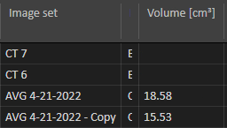 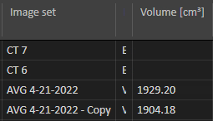 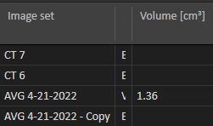

When we run the script, the default selected PTV is the prescription PTV. All plans and additional computed doses on exams with external, E-PTV_Ev20, Lungs-CTV, and a PTV geometry are selected. All stats are selected.

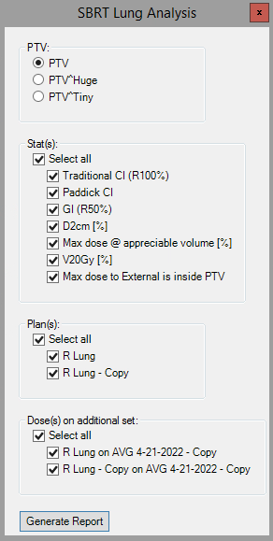

If I select PTV^Huge, all plan and eval dose checkboxes are disabled with a message describing why—the PTV volume is larger than the largest volume in the RTOG 0813 table. The **Generate Report** button is disabled because no plans or eval doses are selected.

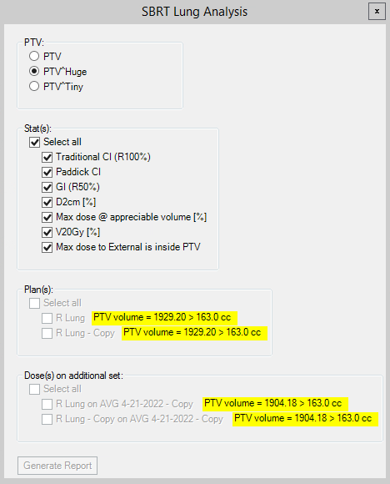

However, if I unselect all interpolated stats, there is no reason to ignore large PTV volumes, so the checkboxes are re-enabled.

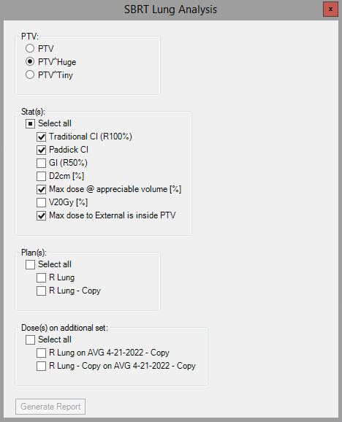

Empty PTV geometries are problematic regardless of the selected, as demonstrated by selecting PTV^Tiny, which is empty on AVG 4-21-2022 - Copy.

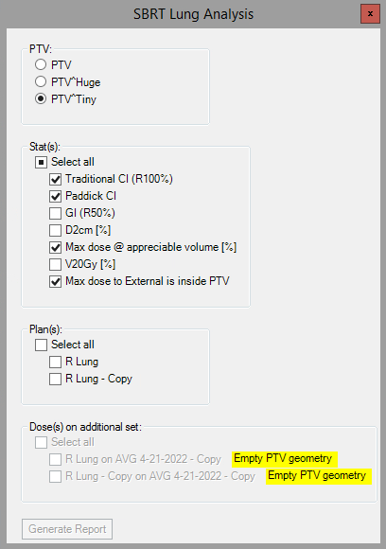

The original default settings in the GUI generate the report Last, First MI R Lung 2022-05-26 10_33_33.pdf:

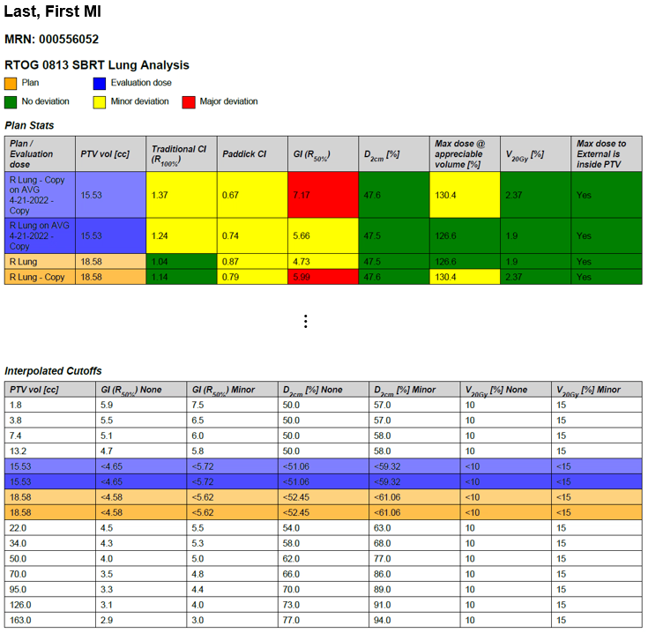

3

3

2

1

Note the following:

1. Key for plan and eval dose colors. Plan rows are orange while eval doses are blue.
2. Key for deviation levels. Stats with no deviation are green, stats with minor deviation are yellow, and stats with major deviation are red.
3. Matching colors in the two tables link each plan / eval dose computed stats and that dose’s cutoffs for minor and major deviations for the interpolated stats. For example, the eval dose R Lung – Copy on AVG 4-21-2022 Copy has minor deviation in traditional and Paddick CI and max dose at appreciable volume, major deviation in GI, and no deviation in the remaining stats. From the **Interpolated Cutoffs** table, we see that the GI stat of 7.17 is above the cutoff for major deviation (5.72).

### Coming Soon

* Test with PTV volumes that are in the RTOG 0813 table and thus do not need interpolation. Likely doesn’t work yet.
* Support all eval dose types, not just dose on additional sets.
* Add patient to dosimetry’s [SBRT Patients](../../RayStation/SBRT/SBRT%20Patients.xlsx) spreadsheet (after it has been cleaned up a bit, such as creating an Excel table from the data).

## Scale Clinical Goals

Scales the plan’s clinical goals to a new dose value. New dose values are rounded to the nearest integer.

Note that goals for homogeneity index are not parameterized by dose and thus are not scalable. These goals are unaffected by the script.

### Assumptions

* A plan is open.
* The open plan contains at least one beam set.
* The open plan set has clinical goals.
* The open plan has “scalable” clinical goals (any type except HomogeneityIndex).

### Approved Plans

If the open plan is approved, the user is offered the option to scale the goals on a copy of the plan.

### Example

Let’s scale clinical goals from 5000 to 6000 cGy.

Before running the script, the plan has these goals:

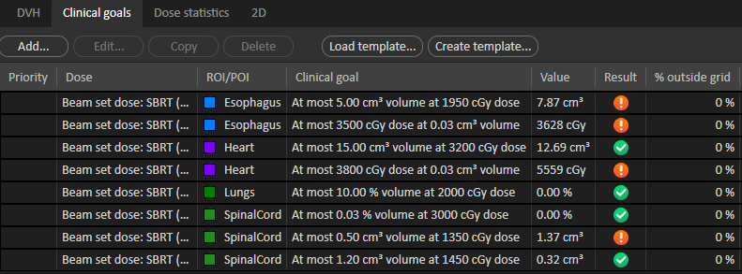

When we run the script, the dose to scale to defaults to the prescription, 5000 cGy:

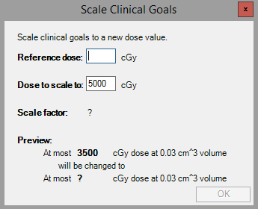

The scale factor cannot be computed yet because a reference dose is not provided. When we fill this in, the scale factor is computed as 6000 / 5000 = 1.2 (the display is rounded to three decimal places). We also see a preview of how one of the goals will be changed. The **OK** button has been enabled because both dose values are valid.

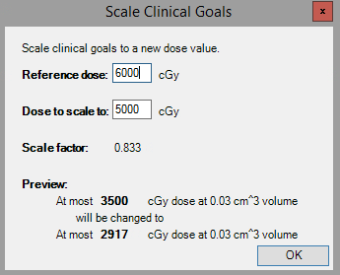

Red indicates an invalid dose value. Dose values must be non-negative integers ≤10000, and the reference dose cannot be zero. Note that the **OK** button is also disabled:

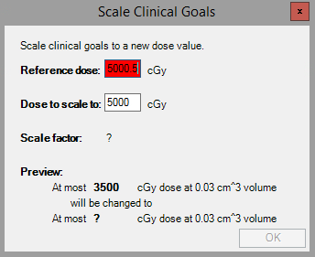

## Scale Objectives and Constraints

Scales the current beam set's objectives and constraints to a new dose value. New dose values are rounded to the nearest integer.

Note that uniform dose constraints are not parameterized by dose and thus are not scalable. These constraints are unaffected by the script.

### Assumptions

* A plan is open.
* The open plan contains at least one beam set.
* The current beam set has an optimization.
* The current beam set has objectives and/or scalable constraints.

### Approved Plans

If the open plan is approved, the user is offered the option to scale the objectives and constraints on a copy of the plan.

### Example

Let’s scale the objectives and constraints from 5000 to 6000 cGy.

Before running the script, the beam set has these objectives and constraints:

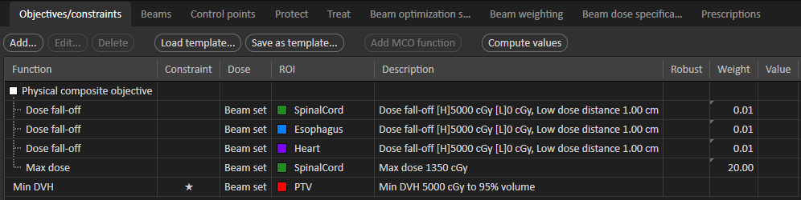

When we run the script, the reference dose defaults to the prescription, 5000 cGy:

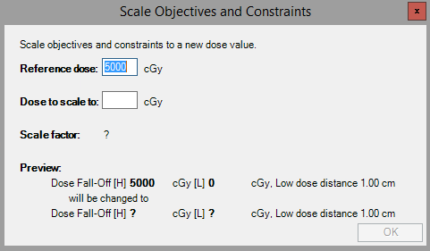

The scale factor cannot be computed yet because a dose to scale to is not provided. When we fill this in, the scale factor is computed as 6000 / 5000 = 1.2 (the display is rounded to three decimal places). We also see a preview of how one of the objectives/constraints will be changed. The **OK** button has been enabled because both dose values are valid.

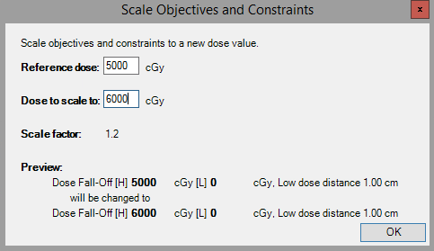

Red indicates an invalid dose value. Dose values must be non-negative integers ≤10000, and the reference dose cannot be zero. Note that the **OK** button is also disabled:

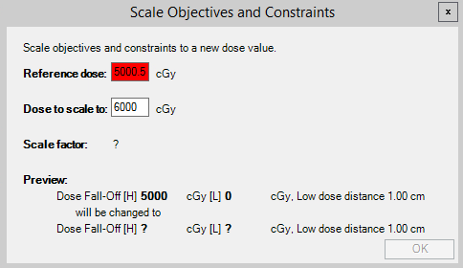

## Show Non-Empty Geometries

[Coming soon]

## Structure Names and Colors

Renames and recolors ROIs and POIs according to TG-263 and CRMC nomenclature and color conventions.

Names and colors come from our TG-263 Nomenclature with CRMC Colors spreadsheet, which is based on the spreadsheet downloaded from the TG-263 website. See the spreadsheet for more information. You should periodically update the spreadsheet with new structure names and colors.

CRMC does not enforce TG-263 nomenclature for targets, but we do use standard colors. The TG-263 names in the spreadsheet that are also target types specify the R, G, and B components of the target color. The A component may be any number between 128 and 255, inclusive; this keeps the same hue but changes the shade. For example, all PTVs should be red (255, 0, 0), but any particular PTV could be (255, 255, 0, 0), (128, 255, 0, 0), (204, 255, 0, 0), etc.



For each ROI and POI, the script first checks for the name in the Possible Incorrect Names table. If the name is listed here as in incorrect name, it is renamed and recolored according to the correct name. If the name is not in this table, the main Names & Colors table is checked. If a match is found, renaming is only necessary is the case does not match. Recoloring may or may not be necessary.

All name comparisons are case insensitive.

When comparing names, copy numbers (which prevent duplicates) and suffixes after a carat are ignored. Copy numbers are removed in the new structure names. Suffixes are added back onto the new ROI name.

### Assumptions

* A case is open.

### Warnings

* Certain structures could not be renamed and/or recolored because they are approved.
* No matching name was found in either the Possible Incorrect Names nor the Names & Colors tables. This is likely due to extra information that should be a suffix after a carat. You should fix these names and rerun the script.

### Example

A case contains these structures:

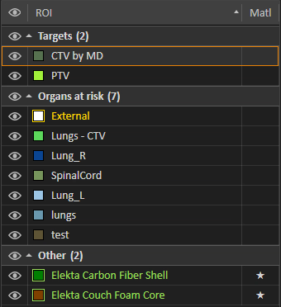

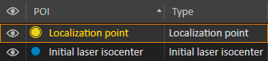

The script corrects the colors of all the structures except External, Elekta Carbon Fiber Shell, and Elekta Couch Foam Core, which are already correct, and test, which is not recognized.

The names are corrected for Lungs - CTV (the spaces are removed), lungs (the capitalization is fixed), and Initial laser isocenter. The name CTV by MD is noncompliant, but target names are ignored.

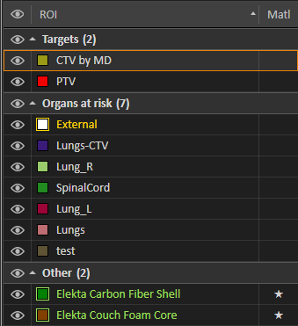

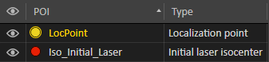

We are prompted to add test to the spreadsheet if appropriate. It is not, so we can ignore this suggestion.

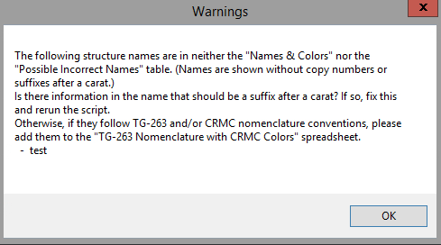

If, before running the script, structures were approved, nothing can be changed, so all the script can do is tell us what needs to be changed.

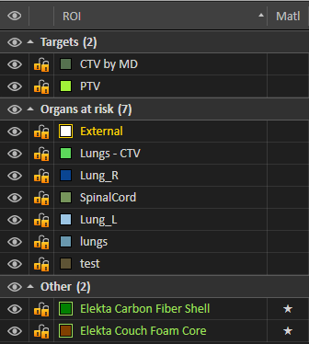

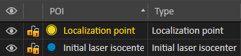

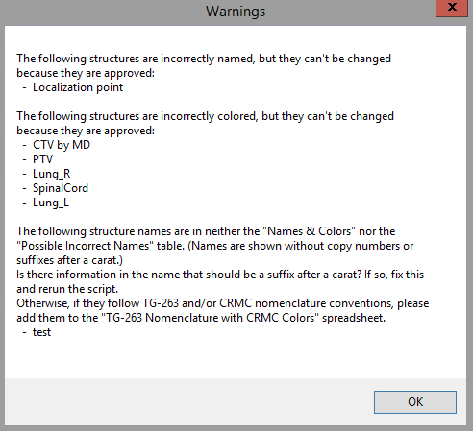

### Coming Soon

* Account for duplicate structure names. For example, if both lung_l and lt lung need renaming to Lung_L, one will become Lung_L (1).
* Remove copy numbers from target names as well as non-target.

## Structure Propagation 4DCT

**\*\*NOT CURRENTLY READY\*\***

### Example

The case has a single 4DCT gated group with images CT 1, …, CT 10. The targets are contoured on CT 1 and CT 2. I’ll use CT 2 as the reference image, and I’ll propagate Lung_L and Lung_R to the other images in the group. I’ll get the center of mass from the PTV.

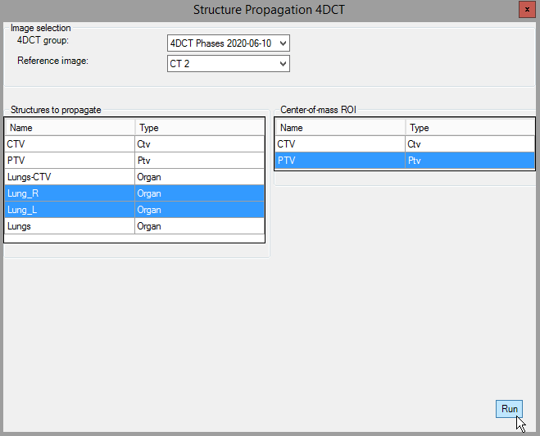

This script takes a while. It may seem as though nothing is happening, but the Run button should be blue after you click it, indicating that the script is running.

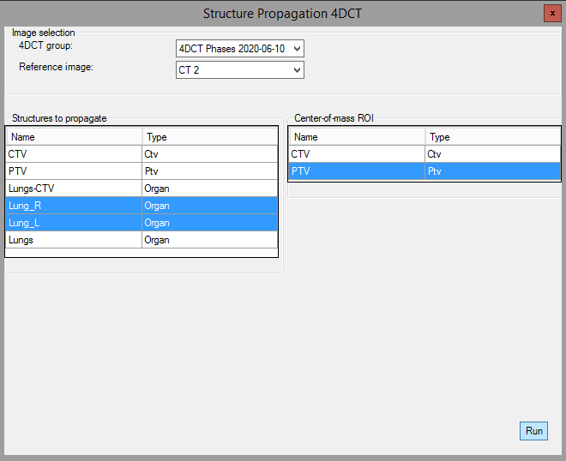

# Other Scripts

## Creating an Executable

Excepting scripts that will be used in RayStation, Python scripts should be converted into executables so that end users can run them without knowing how to run a .py file.

You may create an executable using the Python package [Pyinstaller](https://datatofish.com/executable-pyinstaller/). Delete all files the Pyinstaller creates except the .exe. Move or copy the .exe to a place that end users can easily find it, such as [T:\Physics\Scripts](../../Scripts).

## Info for End Users

Python scripts can be turned into apps that you can run the same way you’d run any other app on your computer: by double-clicking the app. One of these apps looks like this:

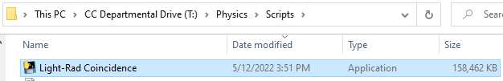

To run Light-Rad Coincidence, just double-click it. You will see an empty black window while the app starts up; this can take several seconds.

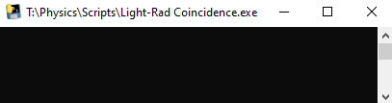

As with any other file, you can, of course, create a Desktop shortcut to an app if you find yourself using it frequently.

## ChromeDefaultBrowser

We recently had an issue with our default browser. Every day when we logged in, we set Chrome as the default browser. But the next morning, the default browser was reset to Edge. It turned out that Group Policy had started resetting everyone's default browser to Edge upon logout. Therefore, in order to use a different default browser, we must manually set it every time we log in. Here is a way to automatically set Chrome as your default browser every time you log in. Like all good IT workarounds, it doesn't require admin permissions.

I got this solution from [Stack Exchange](https://superuser.com/questions/15596/automatically-run-a-script-when-i-log-on-to-windows), [Mark McClelland](https://poetengineer.postach.io/), and [Christoph Kolbicz](https://kolbi.cz/).

### Dependencies

* The browser you want to set as the default. To use the solution as is, this is Chrome.
* Christoph Kolbicz's [SetDefaultBrowser.exe](https://kolbi.cz/blog/2017/11/10/setdefaultbrowser-set-the-default-browser-per-user-on-windows-10-and-server-2016-build-1607)
* This solution was tested in Windows 10, so it is not guaranteed to work with any other operating system.

### Implementation

The batch file ChromeDefaultBrowser.bat runs SetDefaultBrowser.exe (using the absolute path) with the chrome argument:



The file ChromeDefaultBrowser.xml is an exported task from Task Scheduler. Import it into Task Scheduler. The task runs the batch file whenever:

* Your computer is unlocked
* You log in
* You connect to a user session

The following are user-/computer-specific and should be changed:

* The path to SetDefaultBrowser.exe in the batch file. I recommend using the absolute path.
* The path to the batch file in the XML file. The path is inside the <Command> tags.
* Your username in the XML file. This is between the <Author> and the <UserId> tags, where the placeholder is DOMAIN\USER.

## Light-Rad Coincidence

Performs the Winston-Lutz light-radiation coincidence test.

This is truly the poor man's QA software. To perform the test:

1. Irradiate square fields on a piece of film.
2. Scan the film into the computer as a PDF.
3. Run this script. The user chooses the PDF file.
4. The script converts the PDF to a 300dpi image, reads in the image, and annotates the square fields. The field is outlined and labeled with its cm dimensions.
5. The script displays the annotated image.

### Example

1. A physicist irradiated 3×3, 5×5, and 10×10 fields on E2.
2. He scanned the film as letter size on the Dosimetry printer.
3. To measure the fields on the film, run Light-Rad Coincidence.
   1. You will be prompted to select a file:

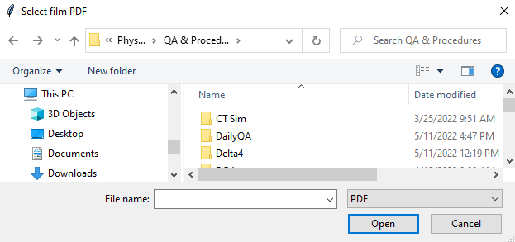

* 1. Navigate to the PDF file, select it, and click **Open**.

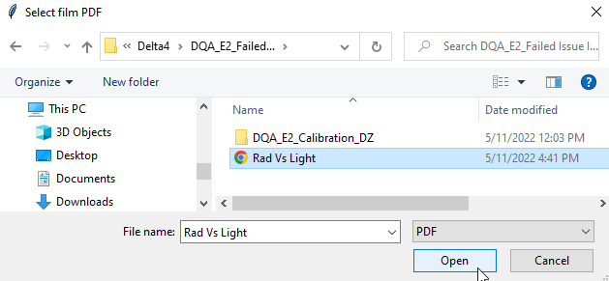

Note that if you close the window (e.g., by clicking the red *X* or the **Cancel** button) the prompt will reappear until a file is actually selected.

* 1. An annotated image will appear. The irradiated fields are outlined in red, and their dimensions (in cm, rounded to two decimal places) are displayed above them.

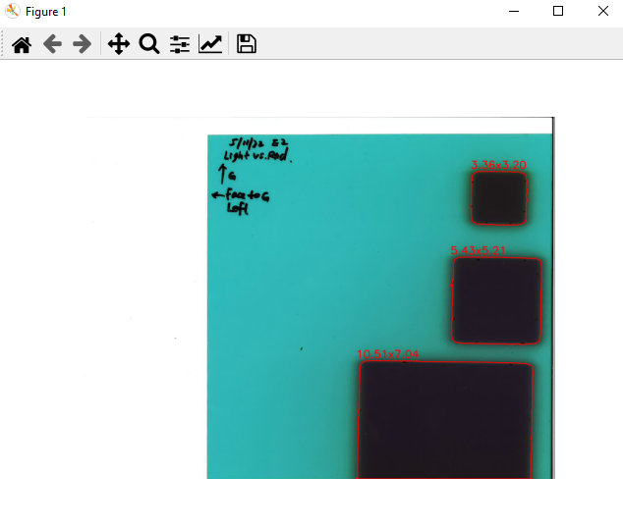

1. To exit the app, close out of the image (e.g., by clicking the red *X*).

## Set CRMC ROI Colors

Sets CRMC conventional colors for a spreadsheet of TG-263 standard ROI names.

We have already done what this script does, but it might come in handy again in the future. AAPM Task Group Report 263 (TG-263) prescribes ROI naming guidelines and includes a downloadable [spreadsheet](https://www.aapm.org/pubs/reports/RPT_263_Supplemental/TG263_Nomenclature_Worksheet_20170815.xls) of standard names. We made the following modifications for our use:

* Corrected a few obvious typos.
* Added some rows with names that CRMC uses or has used before.
* Added a column Named by CRMC, which is FALSE if the row was in the original download and TRUE if we added it.
* Applied Data Validation to several columns.

Manually adding a Color column would have been cumbersome. Instead, we can randomly generate a color for each ROI. There are some ROI colors that we already have preferences for, though, such as blue for Esophagus. The Set CRMC ROI Colors script creates a new spreadsheet that is the user-selected TG-263 spreadsheet without colors, plus a Color column. The user may also specify a spreadsheet of colors that should not be randomly generated. The new spreadsheet is in the same directory as the original spreadsheet and is called TG-263 Nomenclature with CRMC Conventional Colors YYYY-MM-DD HH_SS_MM.xlsx. All colors are in the format (A, R, G, B) and have an A component of 255 (opaque).

The two spreadsheets that the user chooses from a GUI are as follows:

* TG-263 Spreadsheet: A “master” TG-263 nomenclature spreadsheet. If it already has a Colors column, this column is replaced. Must contain a TG-263 Primary Name column. The GUI also includes a link to download the original XLS file from the AAPM website. The script creates the obvious typos in this document and renames the main name column from TG263-Primary Name to TG-263 Primary Name.
* Non-Random Colors Spreadsheet: A spreadsheet containing two columns: TG-263 Primary Name and Color.

Example

Suppose we don’t yet have a TG-263 nomenclature spreadsheet, but we do have a list of preferred colors for some ROIs.

1. The script presents us with this GUI:

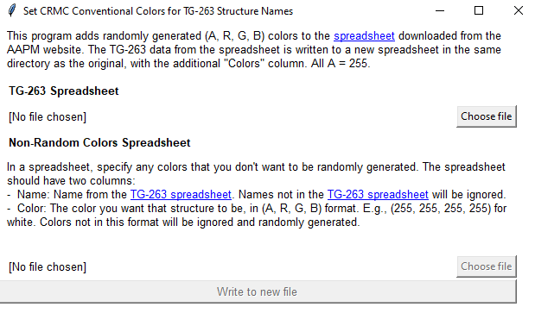

**Links to download TG-263 spreadsheet**

1. Any of the blue links downloads the XLS file from the AAPM website. When I click a blue link, I get these browser windows:

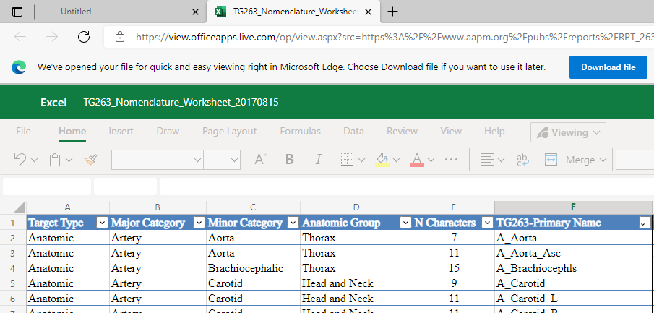

Clicking **Download file** downloads the spreadsheet to my Downloads folder:

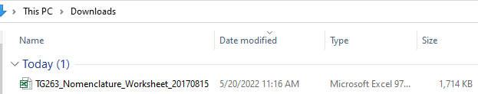

The downloaded spreadsheet looks like this:

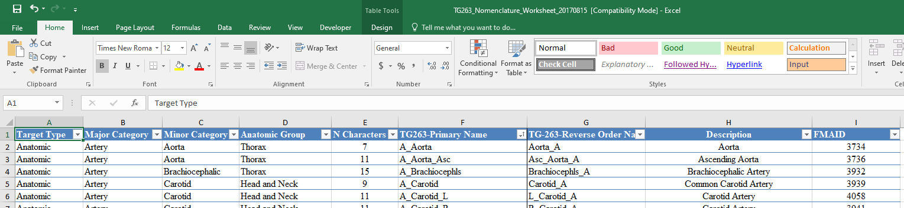

1. Now, I can click the first **Choose file** button in the script GUI and navigate to the downloaded file:

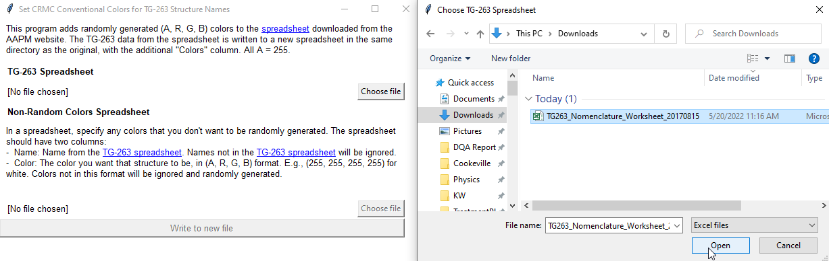

1. Choosing a **TG-263 Spreadsheet** enables the **Choose file** button for the **Non-Random Colors Spreadsheet**, and the **Write to new file** button. If I didn’t have a spreadsheet of non-random colors, I would go ahead and click Write to file, and all colors would be random. Since I do have some prior color preferences, I’ll **Choose file** again:

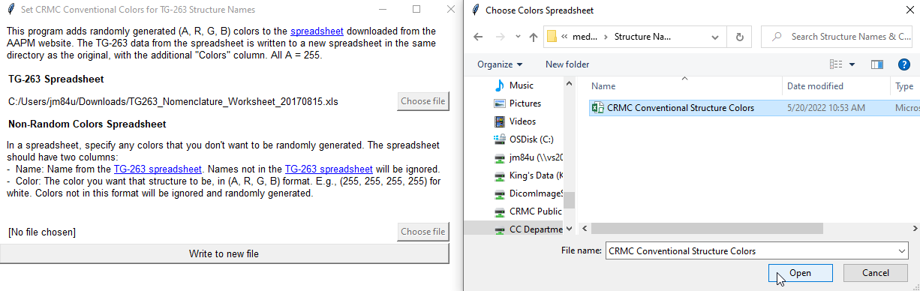

(The **Choose file** button is disabled in the above screenshot because the file dialog has been opened. The button is clickable before that!)

The CRMC Conventional Structure Colors spreadsheet looks like this:

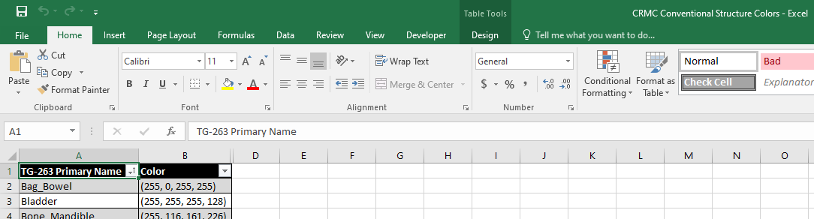

1. Finally, I click **Write to new file**:

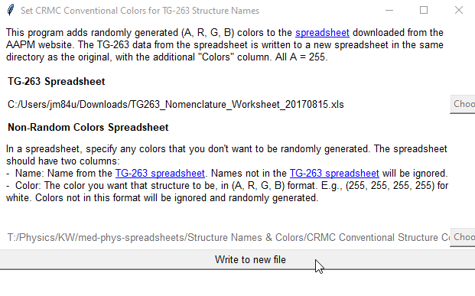

1. And I get a confirmation message that the new file was created successfully:

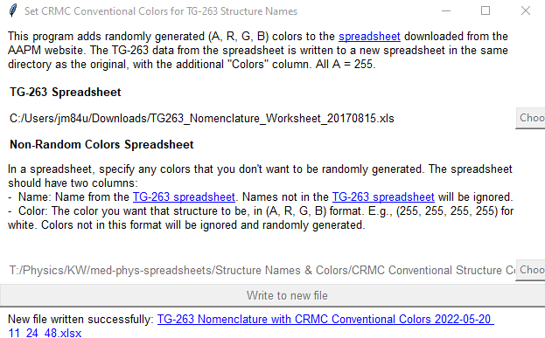

I can click the link to open the new file, which looks like this:

